Tile: Living up here

Overview: Michael talks about the different places he has lived in and why he now lives in Skipton.

Language level: Entry level

Teaching ideas: Entry 1
Link to geography of UK and Citizenship. Listen for cities mentioned in the conversation. Students have names / pictures of 5/10 cities in front of them. Circle / point to the ones they hear. Also comprehension work on how Michael travels to work.

Possible areas to explore according to class interests and level:
Content and comprehension:
Links could be made at all levels to geography of UK and how we describe travelling between places: move up / came over

Career vocab: consultancy / got involved in / etc

Lexis
As above: how we describe travelling between places: move up / came over

Lexical chunks: see notes

Grammar
Use of who / which to describe thins and people. Students notice this use and then describe things from their lives following the model.

Speaking skills
Use of vague language. Students can have a transcript with vague language missing. They have to listen for vague language then practise using it in similar ways in a similar interview.

All images from: http://commons.wikimedia.org/

Transcript

- Emboldened words and chunks indicate colloquial or interesting language use.

No. | speaker | conversation | notes
 | Mary: | Ermm Michael can you tell me about why you live up here in Leeds? Are you a local man? Are you… | Use of Live up here and see note 2
 | Michael: | I’m not a local man, I moved up here I suppose about 10 years ago erm, I had been working in London and then I moved up to Manchester and did some work there in the 1990s early 1990’s and then I got some work in Leeds. I worked for Housing Associations at that time. I was doing some consultancy work with a local Housing association in Leeds called Unity Housing Association which is a Black Housing Association. A friend of mine was running it and needed some work doing so I came over to do that. I needed to live somewhere and I had a friend who lived in Skipton so I stayed in his house and a bit like a cuckoo I’ve stayed there ever since so it all kind of went from that and then I got involved in English and English Language teaching, went abroad but then was always coming back to Skipton as my base and then in recent years I did my Masters at Leeds Metropolitan University and started to work for Leeds Met so that’s how I ended up … | Note moved up. Up is repeated as Michael has come to the north from London  and a bit like a cuckoo  What is this reference about?  I got involved in  was always coming Note use of always with past continuous for repeated action  Leeds Met abbreviated in repetition  that’s how I ended up a lexical chunk typically used as concluding marker
 | Mary: | And are you happy living in Skipton?
 | Michael: | Yeah I love it. I think it’s a lovely little place, nice little market town erm and I like it a lot. The only problem is that I’m one and a half hours to get into Leeds and another hour and a half to get back to Skipton in the evening.. | lovely little place  nice little market town  use of little often implies fondness. Linked here to lovely and nice
 | Mary: | By car, by train?
 | Michael: | By train
 | Mary: | By train …
 | Michael: | I have to change in Leeds and go out to Headingly so I’m probably about 3 hours travelling which is too much ... I’ll have to do something about that in..at some point

Canal in Skipton

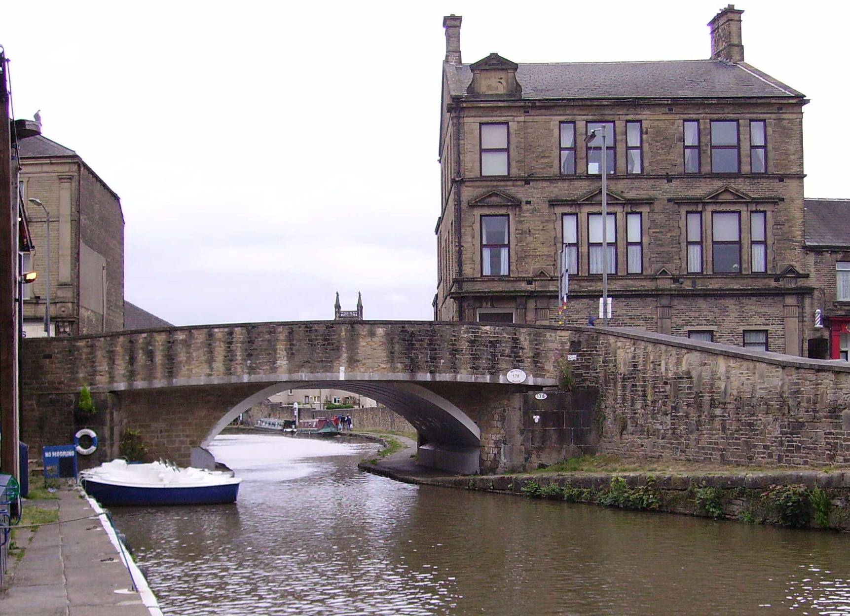

Train to Skipton
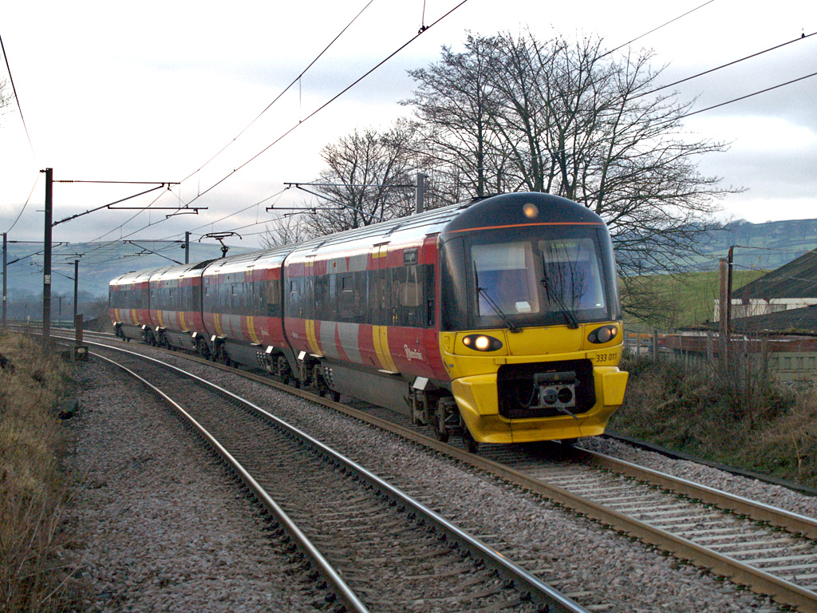

Headingley
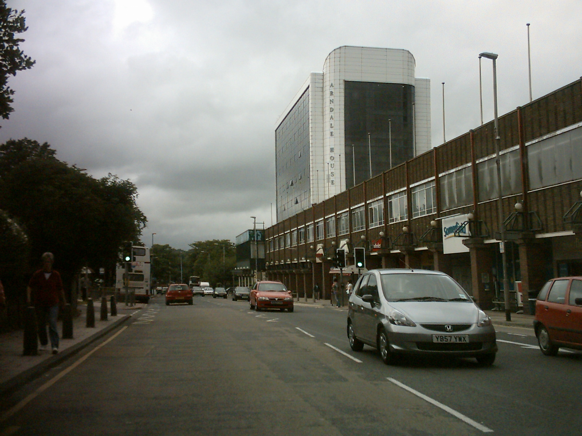

Leeds Metropolitan University
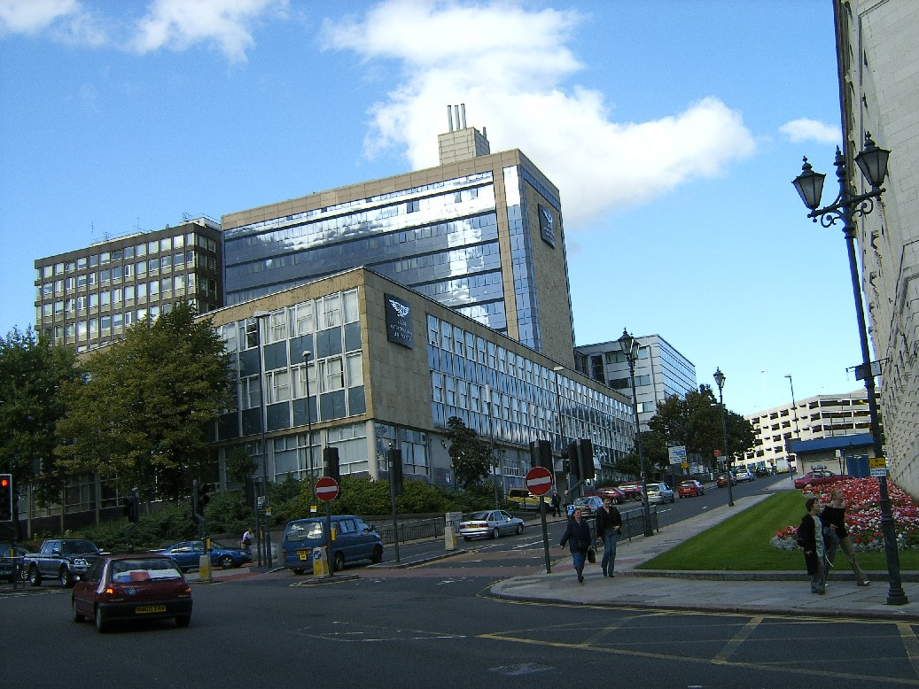

Flea market Skipton
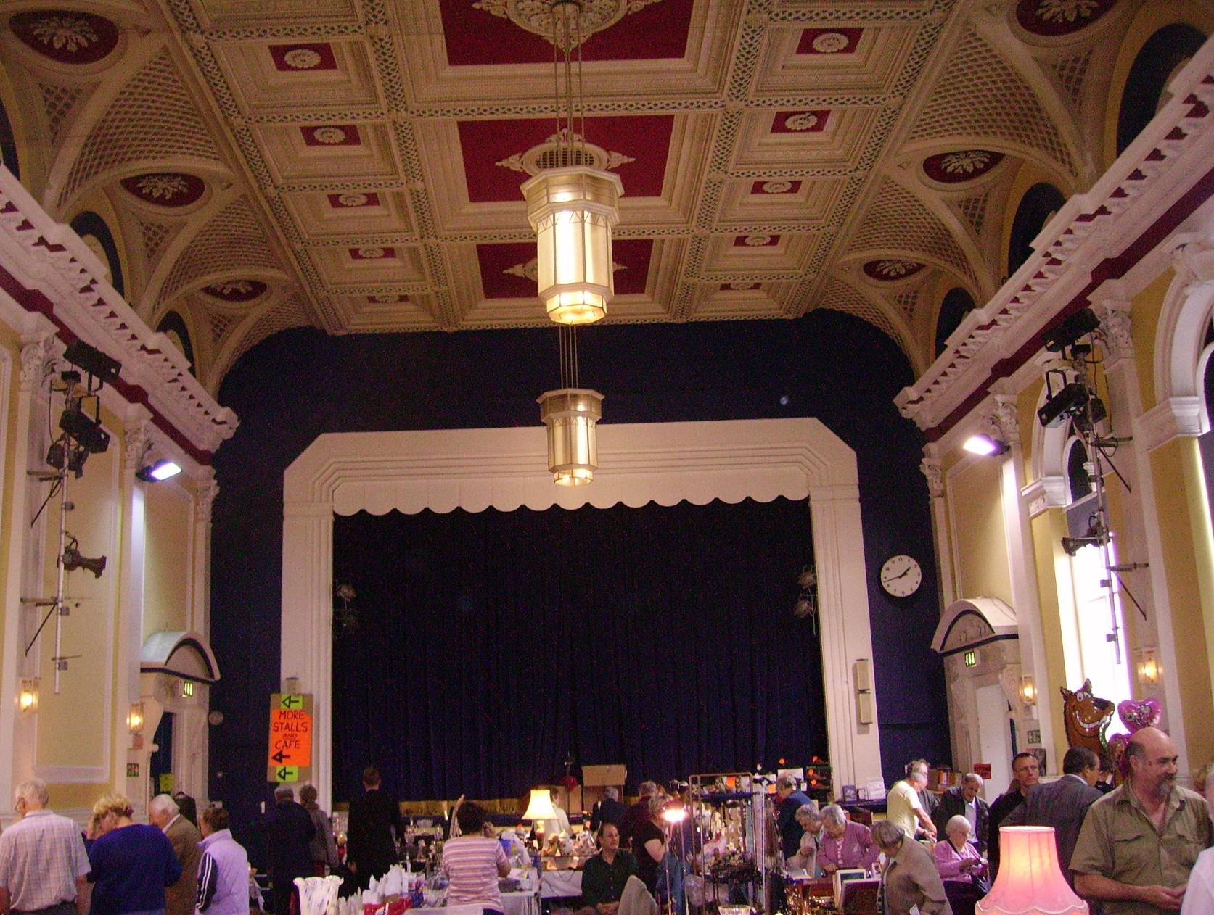

Market stalls in Skipton


