 | in  Name: _______________________________ Date: ______________ | it  tutor note: see back page
1
2
3
4

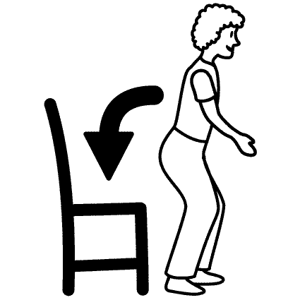 | 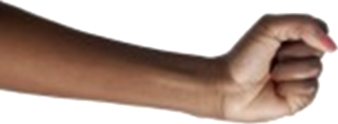 |  | 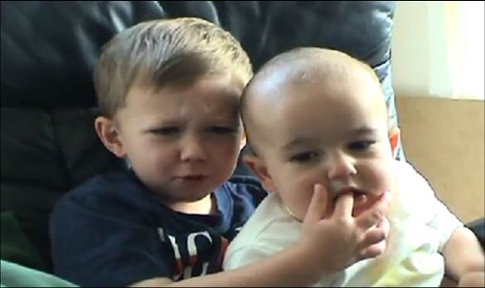
 | 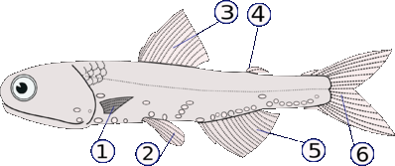 | 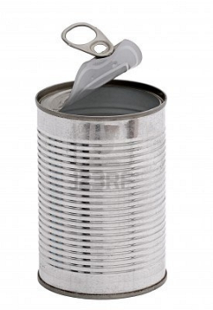 | 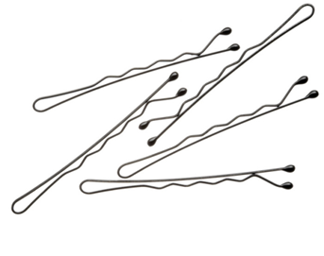

Words (open PowerPoint - Week 9 Words 1)

 | spellings (listen to the tutor) | correct

(Open PowerPoint - Week 9 Sentences 1)

Read the sentences with your tutor and copy the sentences neatly.

 | 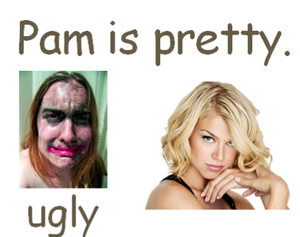 | 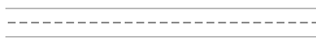
 | 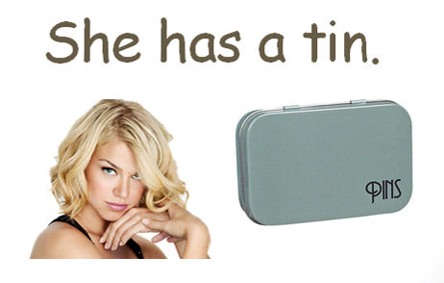
 | 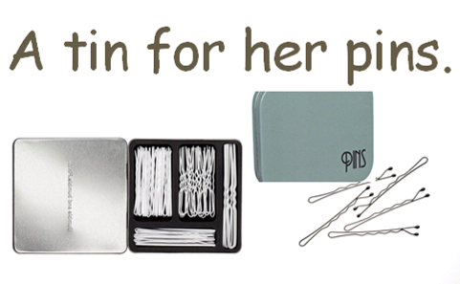
 | 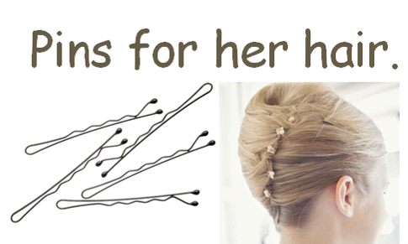
 | 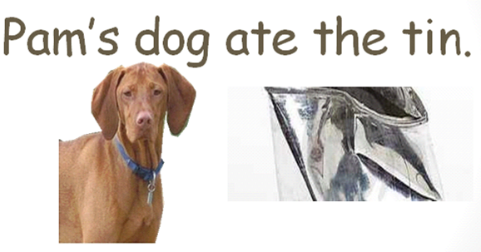
 | 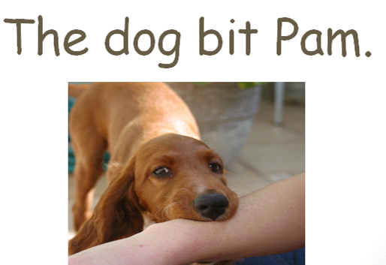
 | 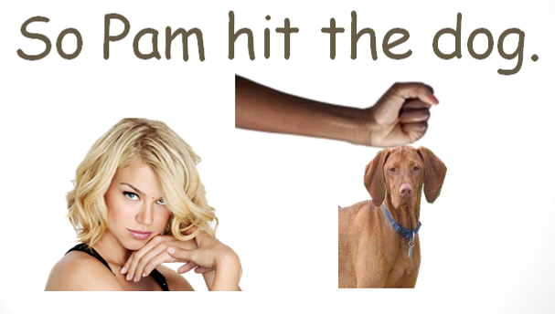
 | 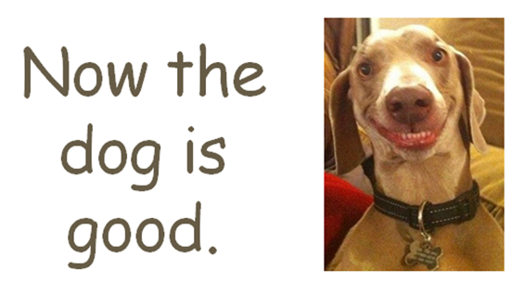
 | 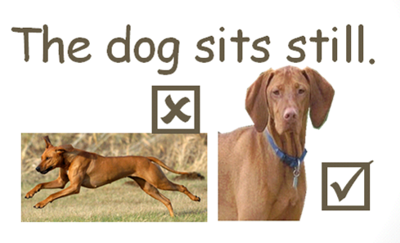
 | 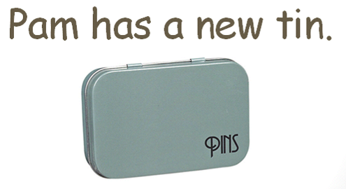

STUDENT 1 - in pairs, read the sentences to the other student and copy.

Pam is pretty.
___________________________________________
A tin for her pins.
___________________________________________
Pam’s dog ate the tin.
___________________________________________
So Pam hit the dog.
___________________________________________
The dog sits still.
___________________________________________

Rewrite if you have mistakes.

Pam is pretty.
___________________________________________
A tin for her pins.
___________________________________________
Pam’s dog ate the tin.
___________________________________________
So Pam hit the dog.
___________________________________________
The dog sits still.
___________________________________________

STUDENT 2 - in pairs, read the sentences to the other student and copy.

___________________________________________
She has a tin.
___________________________________________
Pins for her hair.
___________________________________________
The dog bit Pam.
___________________________________________
Now the dog is good.
___________________________________________
Pam has a new tin.

Rewrite if you have mistakes.

___________________________________________
She has a tin.
___________________________________________
Pins for her hair.
___________________________________________
The dog bit Pam.
___________________________________________
Now the dog is good.
___________________________________________
Pam has a new tin.
word shapes (lowercase letters)

1 2 3

4 5 6

7 8 9 10

Pam dog new still good

ate hair pins pretty sits

word search (capital letters) online click here to create more

T | T | C | T | F | D | P | M | T | J
A | A | H | A | I | R | R | W | K | W
D | J | S | I | T | S | K | E | I | U
P | A | M | O | X | N | E | W | J | C
E | P | I | N | S | F | E | U | W | X
O | Y | R | S | T | I | L | L | T | C
D | O | G | G | G | V | P | G | V | G
D | A | T | E | F | D | H | O | O | L
G | O | O | D | X | I | A | U | S | D
Z | P | R | E | T | T | Y | Y | H | T

Order the sentences (this could be done orally, reading aloud and learners copy)
 | Sentences | Rewrite if incorrect
 | is pretty. Pam
 | a tin. She has
 | A tin her pins. for
 | her hair. Pins for
 | Pam’s the tin. dog ate
 | bit Pam. The dog
 | So the dog. Pam hit
 | the is good. dog Now
 | sits still. The dog
 | new tin. Pam has a

Write ‘has’ or ‘have’ below.
(I, we, they) = have (2+) ‘Have’ is used with some pronouns and plural nouns.

(she, he, it) = has (1) ‘Has’ is used with the third person singular and singular nouns.

Pam _____ a tin.
I _____ a tin.
I _____ pins.
The dog _____ a tin.
Pam _____ a new tin.
She _____ pins.
Pam _____ a dog.
I _____ a dog.
The dog and me _____ a tin.
I _____ a new tin.

Spellings
- Pam pam Pem is his pretty prety preti.
- She she Sha has his her a tin ten tni.
- A tin ten tni for her has his pins pin pens.
- pins Pins pens for foor her hair hiar hairs.
- Pam’s pam dog ate eta ate the tin ten tni.
- The dog bit bite bites Pam.
- so So Pam hit hat hot the dog mog log.
- Now the dog mog log is gud god good.
- The dog sits sat sit stall stil still.
- Pam has his her a now neew new tin.

Look at the words below and write sentences using has and have.
bin pen hen pan mop box jug rug cup mug

(I, we, they) = have (2+)

(she, he, it) = has (1)

Pam has a mug.
I
They
She
He
The dogs
The teacher
Bob
We

Rewrite this using full-stops correctly and capital letters.

pam is pretty she has a tin a tin for her pins pins for her hair
pam’s dog ate the tin the dog bit Pam so Pam hit the dog
now the dog is good she dog sits still pam has a new tin
_______________________________________________
___________________________________________________________________________________________________________________________________________________________________________________________________________________________________________

In pairs, ask each other these questions and answer, repeating the end of each question in the answer. Write down your answers.

1.) Is Pam pretty? _______________________________

2.) Where are her pins? _______________________________

3.) What did the dog eat? _______________________________

4.) What did the dog bite? _______________________________

5.) What is the dog called? _______________________________
Lesson 2
tutor note: see back page

win feet stop

tired race outside

 | 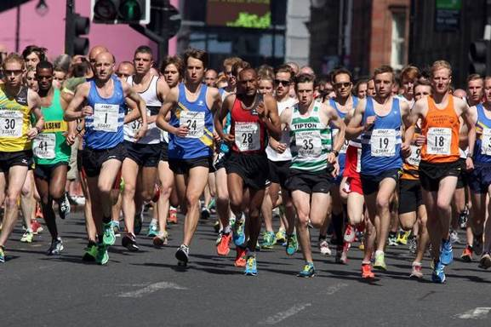
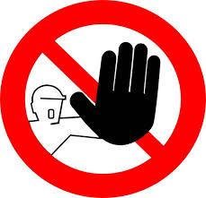 | 
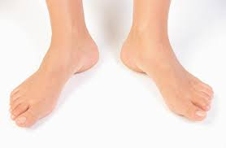 | 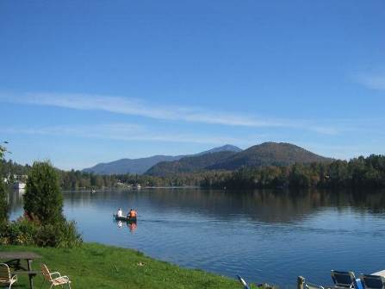

Words (open PowerPoint – Week9 Words 2)

 | spellings (listen to the tutor) | correct

(Open PowerPoint – Week 9 Sentences 2)

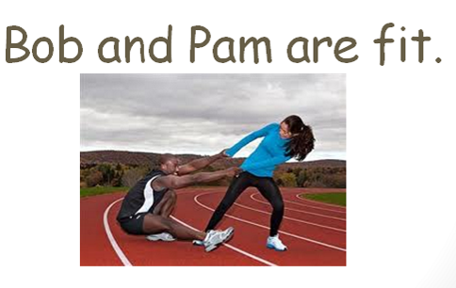
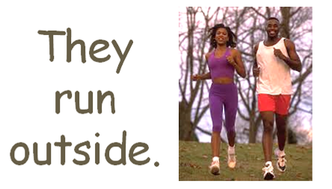
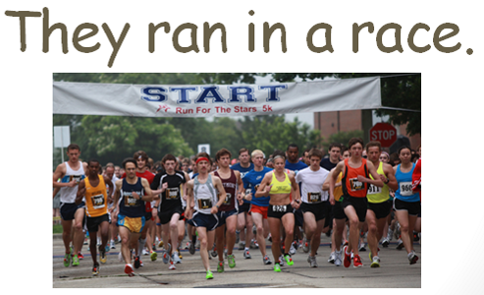
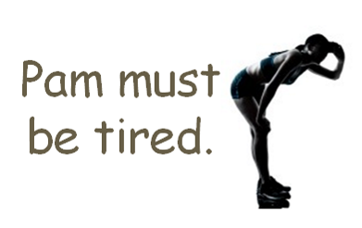
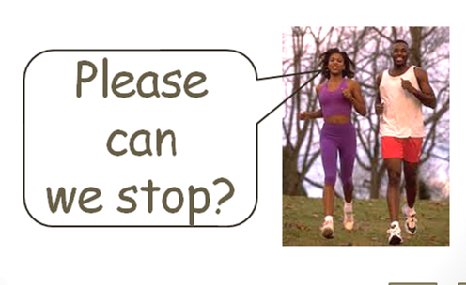
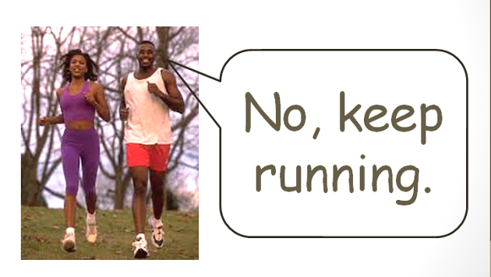
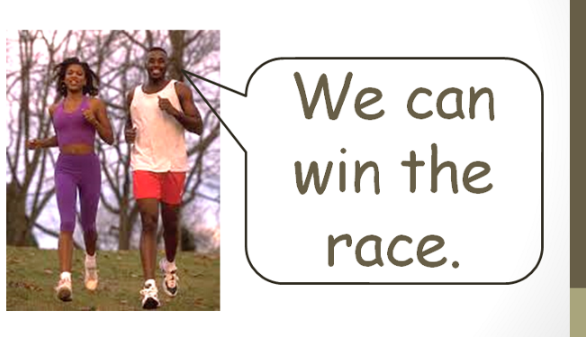
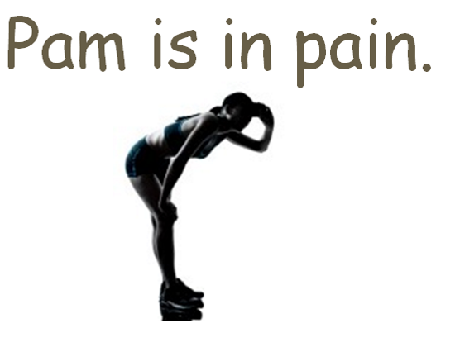
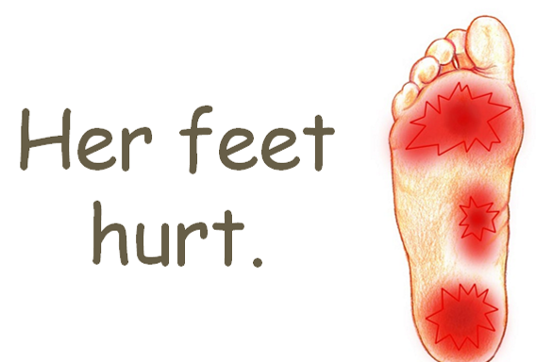
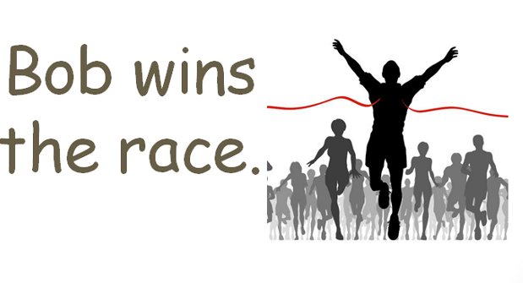
STUDENT 1 - in pairs, read the sentences to the other student and copy.

Bob and Pam are fit. ___________________________________________
They ran in a race. ___________________________________________
Please can we stop?
___________________________________________
We can win the race.
___________________________________________
Her feet hurt.
___________________________________________

Rewrite if you have mistakes.

Bob and Pam are fit.
___________________________________________
They ran in a race.
___________________________________________
Please can we stop?
___________________________________________
We can win the race.
___________________________________________
Her feet hurt.
___________________________________________

STUDENT 2 - in pairs, read the sentences to the other student and copy.

___________________________________________
They run outside.
___________________________________________
Pam must be tired.
___________________________________________
No, keep running.
___________________________________________
Pam is in pain.
___________________________________________
Bob wins the race.

Rewrite if you have mistakes.

___________________________________________
They run outside.
___________________________________________
Pam must be tired.
___________________________________________
No, keep running.
___________________________________________
Pam is in pain.
___________________________________________
Bob wins the race.
Word shapes (lowercase letters)

1 2 3

4 5 6

7 8 9

outside race tired heat please stop keep

feet hurt win

Word search (capital letters)

L | R | H | T | I | R | E | D | I | F
U | S | N | D | F | P | D | I | F | C
M | O | L | R | S | H | U | R | T | W
K | P | L | E | A | S | E | Y | M | F
H | E | A | T | W | I | N | Y | S | X
J | E | T | U | V | A | D | B | U | W
O | O | U | T | S | I | D | E | Y | C
S | T | O | P | F | E | E | T | E | C
K | K | E | X | Y | P | P | R | M | Z
K | E | E | P | R | A | C | E | Q | Y
Spellings (circle the correct words)

- Pam pam Pem is his pretty prety preti.
- Bob/bobb/boob / and / Pam/mpa/map / are / fit/fitt/fat.

- They/thay/the / ran/rin/run / in / a / race/racce/rice.

- Pam/map/pan / must/most/musst / be/bee/bi / tried/tired/tyred.

- Pleease/please/plees / can/cant/cann / way/wee/we /stopp/stap/stop.

- No/not/non / kept/keap/keep / ranning/runing/running.

- we/We/wee / can/Cann/cant / won/win/winn / the / raace/rase/race.

- Map/Pam/pamm / is / in / pane/plain/pain.

- Hair/her/heir / feet/feat/fit / heart/hurtt/hurt.

- Bobb/Bob/bib / win/winn/wins / the / rase/racce/race.

Order the sentences
Use capital letters at the start of each sentence and full-stops.

 | Sentences | Rewrite if incorrect
 | fit are Pam Bob and.
 | run outside they.
 | a in they ran race.
 | be must tired Pam.
 | we stop can please ?
 | no, running keep.
 | can win we race the.
 | pain in is Pam.
 | feet hurt Her.
 | race wins the Bob.
Write sentences using negative contractions.
has not = hasn't | have not = haven't
(she, he, it) = has (1) | (I, we, they) = have (2+)

bin dog pan mop box jug rug cup mug

Stephen hasn’t got a pen.
I
They
She
He
You
Pam
Bob
We

Contractions
I have = I've | you have = you've | we have = we've
they have = They've | he has = he's

Write the sentences
Bob has a dog. | Bob’s got a dog.
Bob has a bin. | got a bin.
We have a race. | got a race.
Pam has sore feet. | got sore feet.
Pat has pins. | got pins.
She has a tin. | got a tin.
We have a dog. | got a dog.

Negative contractions
has not = hasn't | have not = haven't

Write the sentences
Bob has a dog. | Bob hasn’t | got a dog.
Bob has a bin. | Bob | got a bin.
We have a race. | We | got a race.
Pam has sore feet. | Pam | got sore feet.
Pat has pins. | Pat | got pins.
She has a tin. | She | got a tin.
We have a dog. | We | got a dog.
Rewrite this using full-stops correctly and capital letters.

bob and Pam are fit they run outside they ran in a race
pam must be tired please can we stop no, keep running
we can win the race pam is in pain her feet hurt bob wins the race
_______________________________________________
___________________________________________________________________________________________________________________________________________________________________________________________________________________________________________

In pairs, ask each other these questions and answer, repeating the end of each question in the answer. Write down your answers.

1.) Who is bob’s wife? _______________________________

2.) Where do they run? _______________________________

3.) Is Pam tired? _______________________________

4.) What hurts? _______________________________

5.) Who wins the race? _______________________________

Spelling activity (at home)
Write down 10 words you want to learn to spell. Practise spelling the words correctly.
Use LOOK SAY COVER WRITE CHECK

SPELLINGS

 | word | syllables | 1st try | 2nd try | 3rd try | 4th try
1
2
3
4
5
6
7
8
9
10

 | in | it  tutor note: see back page
1 | fin | bit
2 | pin | fit
3 | tin | hit
4 | pain | sit

