 | et | eg | ick
1 |  | leg
2 |  | beg
3
4
Name: _______________________________ Date: ______________

tutor note: see back page

 | 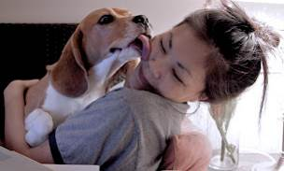 | 
 |  | 
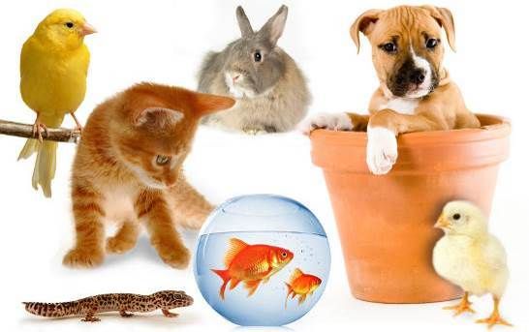 | 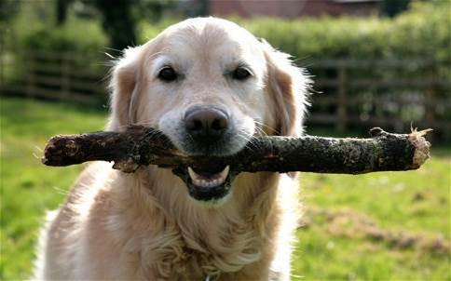 | 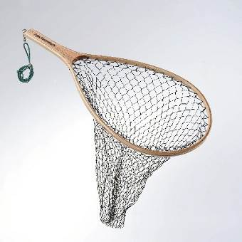

Words

 | spellings (listen to the tutor) | correct

 |  | 
 | 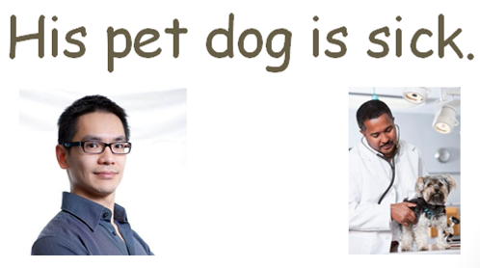
 | 
 | 
 | 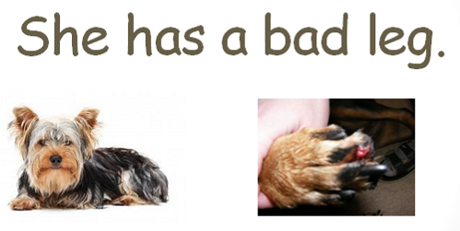
 | 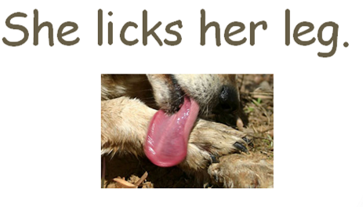
 | 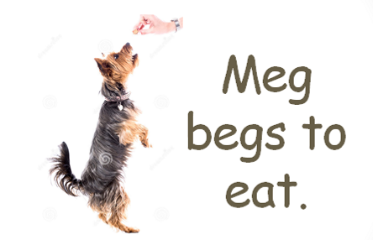
 | 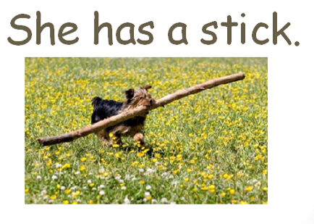
 | 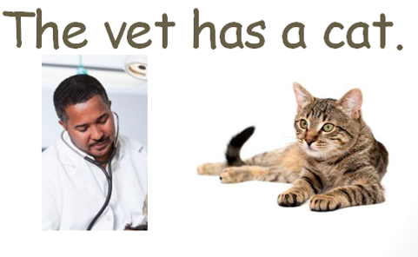
 | 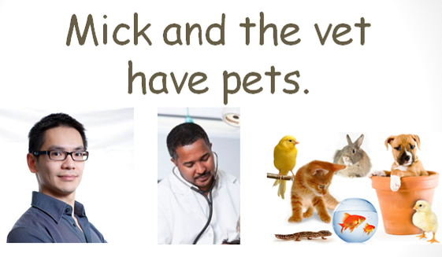

Order the sentences
Use capital letters at the start of each sentence and full-stops.

 | Sentences | Rewrite if incorrect
 | the vet. mick met
 | is sick. pet dog his
 | the did eat? dog
 | meg eat meat. did
 | bad leg. has a she
 | she her leg. licks
 | to eat. meg begs
 | a stick. has she
 | a cat. the vet has
 | mick pets. the vet and have

Spellings (circle the correct words)

- Mick Mik Mic / met mat meet / the thee / vat vet
- His his hes / pet peet pat / dog dag / is / sick sic sik.
- Did deed / the thee / dog dag / eat eet aet?
- Meg mag meg / did deed / eat aet eet / meat meet.
- she shee She / has his her / a / bad bed / leg lag log.
- she She / licks lics liks / her his had / leg lag log.
- Meg mag meg / begs beg bigs / to / eat eet aet.
- she She / has his hed / a / stick stik.
- The the / vet vat veet / has his her /a / cat cut.
- Mick / and / the / vet / have has / pets pet.

Spelling activity (at home)
Write down 10 words you want to learn to spell. Practise spelling the words correctly.
Use LOOK SAY COVER WRITE CHECK

SPELLINGS

 | word | syllables | 1st try | 2nd try | 3rd try | 4th try
1
2
3
4
5
6
7
8
9
10

