Clothes and people

Pronoun (P) | Auxiliary verb (AV) | Verb (V) | Pronoun (P) | Noun (N)
She | is | wearing | her | Dress | 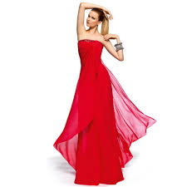
They | are | wearing | their | trousers | 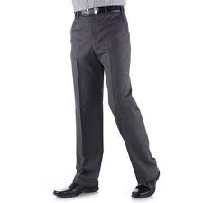
He | is | wearing | his | socks | 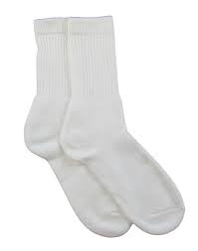
He | is | wearing | his | Shirt and tie | 
She | is | wearing | her | skirt | 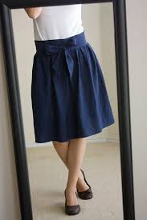
He | is | wearing | his | suit | 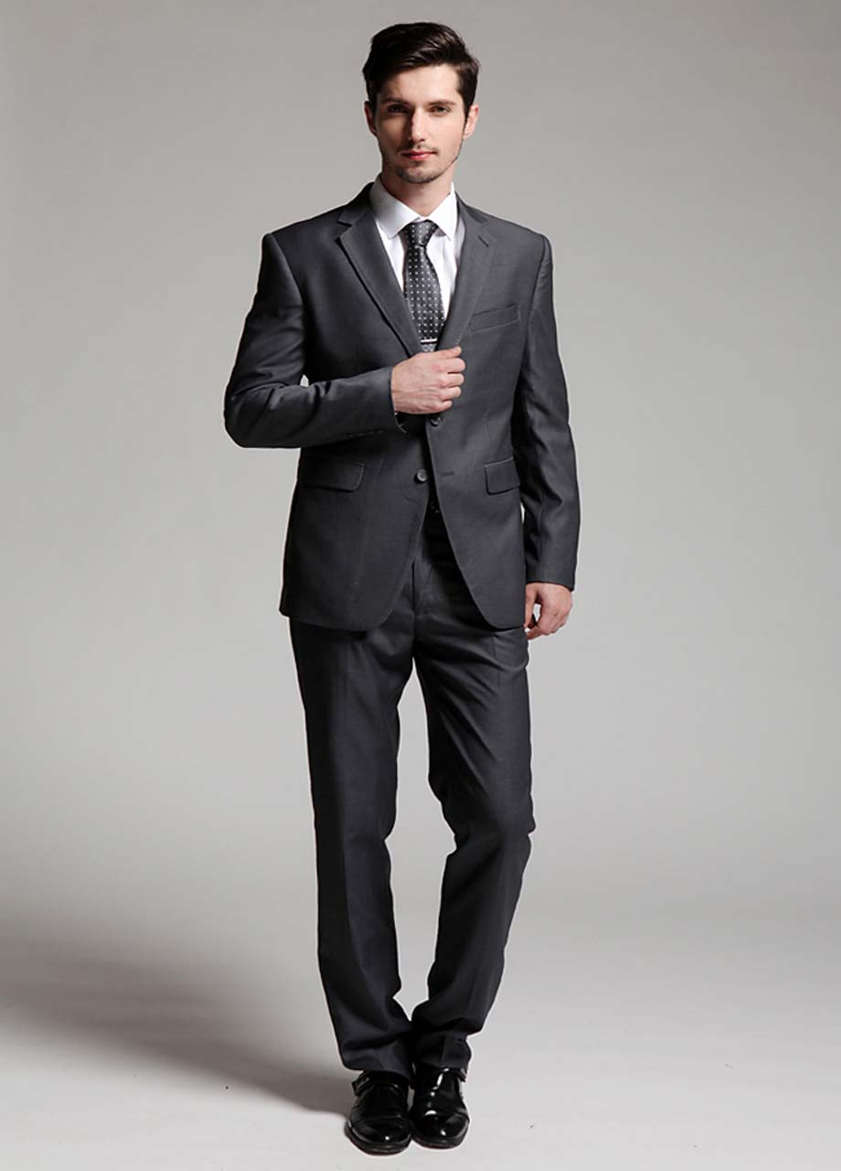

Complete
She is wearing
They are wearing
He is wearing
He is wearing
He is wearing
They are wearing

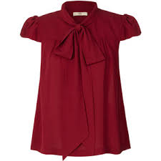 | 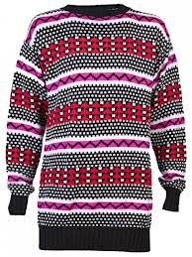
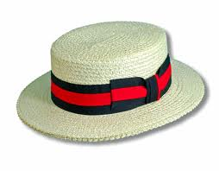 | 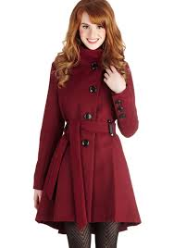
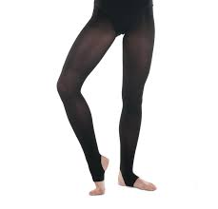 | 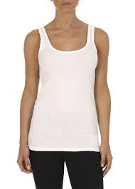
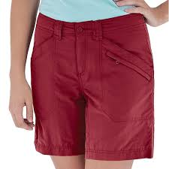 | 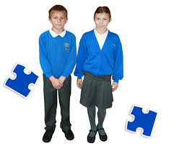

Blouse | Hat | Coat | School uniform
Tights | Shorts | Vest | Jumper

Suit skirt shirt blouse socks trainers trousers dress coat t-shirt tights hat shorts vest jumper boots

Man | Woman | Both

Ask each other. Can you add any more words to these clothes?

Describing clothes

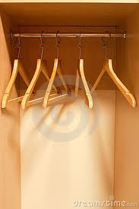
This is my wardrobe. These are my coat hangers.
In my wardrobe I have 6 special things:
- A beautiful red dress.
- Some long black trousers.
- A soft green blouse.
- A warm brown coat.
- An expensive yellow jumper
- Some tiny pink shorts.
Article (A) | Descriptive adjective (Adj) | Colour adjective (Adj) | Noun (N)
A | beautiful | red | dress
Some | smart | black | trousers
A | warm | brown | coat
An | expensive | yellow | jumper
Some | tiny | pink | shorts.
A | soft | green | blouse.

Copy the sentence and write it next to the picture:

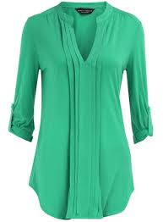 | 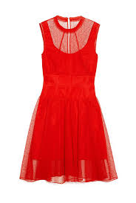 | 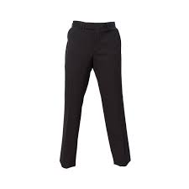
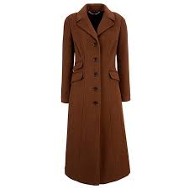 | 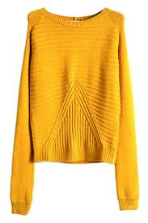 | 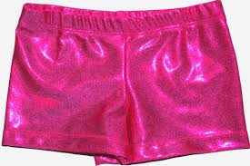
What are you wearing today?

ASK the class. Write a sentence about AT LEAST two people.

First, you:
Today, I am wearing
_____________________________________________________________

Name | What are they wearing?
Elisa | She is wearing
Adji | She is wearing
Somia | She is wearing
Maria | She is wearing
Sabrya | She is wearing
Regat | She is wearing
Yohannis | She is wearing
Ali | He is wearing
Shilan | She is wearing
Inga | She is wearing
Helena | She is wearing
Gyaband | She is wearing
Nimo | She is wearing
Shunim | She is wearing
Wei | He is wearing
Intisar | She is wearing
Jennifer | She is wearing

Do you remember the Slimm family?

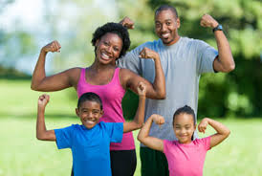

This is Mum. She is called Pam.
This is Dad. He is called Tim.
This is the daughter. She is called Eve.
This is the son. He is called Adam.

What are the Slimms wearing? Complete:

Mum is wearing a pink
Dad is wearing a grey
Eve is wearing a pink
Adam is wearing a blue

The Slimm Family’s washing line

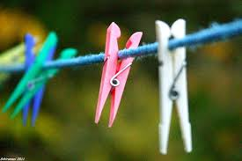

- This is the Slimm family’s washing line and clothes pegs.
- Pam is the Mother. She does the washing.
- She is married to Tim. He helps with the washing.
- They have two children called Eve and Adam.
- The family wear lots of different clothes.
- Pam loves to wear dresses. She has a long purple dress.
- Tim always wears a smart black suit to work. His tie is blue.
- Pam has to wash her children’s clothes every day.
- Pam hangs the clothes out to dry on the washing line.
- Adam goes to school. He wears a smart grey school uniform.
- Eve goes to school. She has a short blue skirt and a soft white blouse.

Where do the family live? | They live in …
Who does the washing?
What does Pam like to wear? | She likes to wear
What does Tim like to wear? | He likes to wear
What does Eve wear for school? | She wears
What does Adam wear for school? | He wears

Complete:

Pam wears:

a | long | purple | dress

Tim wears:

Adam wears:

Eve wears:

Auxiliary verbs – be/do/have

An auxiliary verb helps the main (full) verb and is also called a "helping verb." The verb forms of be, do, and have can be used either as a main (full) verb or an auxiliary verb.

(present)
Be  Is / am / are / isn’t / aren’t | Do  Do / does / doesn’t /doing |  |  | Have  Have / has / having / haven’t / hasn’t
(past)
was / were |  | did | had
(examples)
I am listening.  We are listening.  She is listening. |  | I do exercise.  She does exercise.  We are doing exercise. | I have one child.  She has two children.  We are having our breakfast.

Complete the text with the correct auxiliary verb

- This ____ the Slimm family’s washing line and clothes pegs.
- Pam _____ the Mother. She _____ the washing.
- She _____ married to Tim. He helps with the washing.
- They ______ two children called Eve and Adam.
- The family wear lots of different clothes.
- Pam loves to wear dresses. She _____ a long purple dress.
- Tim always wears a smart black suit to work. His tie _ blue.
- Pam ___ to wash her children’s clothes every day.
- Pam hangs the clothes out to dry on the washing line.
- Adam goes to school. He wears a smart grey school uniform.
- Eve goes to school. She _____ a short blue skirt and a soft white blouse.

Auxiliary verbs – be/do/have

An auxiliary verb helps the main (full) verb and is also called a "helping verb." The verb forms of be, do, and have can be used either as a main (full) verb or an auxiliary verb.

(present)
Be  Is / am / are / isn’t / aren’t | Do  Do / does / doesn’t /doing |  |  | Have  Have / has / having / haven’t / hasn’t
(past)
was / were |  | did | had
I was at the cinema yesterday.  We were at the gym on Saturday. |  | Did you see the news last night?  I did my homework. | I had a good time at the party.  They had their breakfast at 8.00am.

Look at the text again. Put the auxiliary verbs into their PAST form.

- This ____ the Slimm family’s washing line and clothes pegs.
- Pam _____ the Mother. She ______ the washing.
- She _____ married to Tim. He helped with the washing.
- They ______ two children called Eve and Adam.
- The family wore lots of different clothes.
- Pam loved to wear dresses. She _____ a long purple dress.
- Tim always wore a smart black suit to work. His tie __ blue.
- Pam ___ to wash her children’s clothes every day.
- Pam hung the clothes out to dry on the washing line.
- Adam went to school. He wore a smart grey school uniform.
- Eve went to school. She ______ a short blue skirt and a soft white blouse.
What are they wearing?
Write some sentences to describe the people

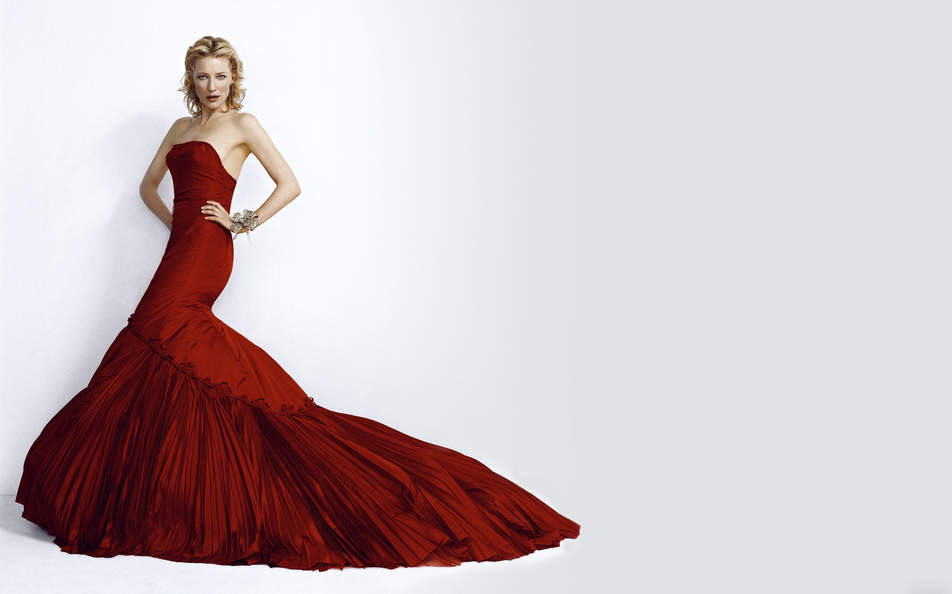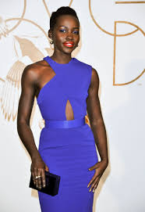
She is wearing | She is wearing

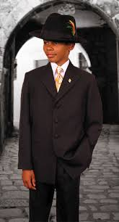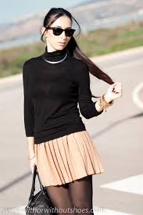
He is wearing | She is wearing

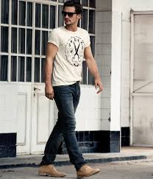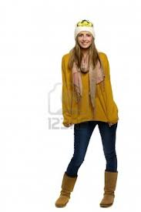
He is wearing | She is wearing

Noun Gap Fill

- This is the Slimm family’s ___________ and clothes pegs.
- Pam is the _________. She does the ____________.
- She is married to Tim. He helps with the washing.
- They have two __________ called Eve and Adam.
- The family wear lots of different ___________.
- Pam loves to wear dresses. She has a long purple _______.
- Tim always wears a smart black ______ to work. His _____ is blue.
- Pam has to wash her children’s clothes every day.
- Pam hangs the washing out to dry on the washing line.
- Adam goes to school. He wears a smart grey _____________.
- Eve goes to _________. She has a short blue _______ and a soft white _________.

washing line | mother
washing | children
clothes | dress
suit | tie
school uniform | school
skirt | blouse

