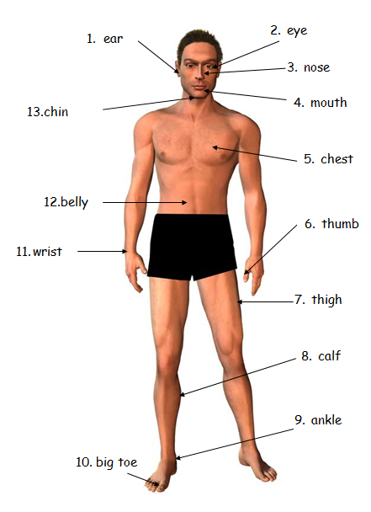

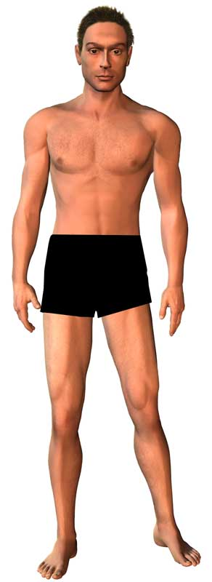
1
2
3
4
5
6
7
8
9
10
11
12
13

The present simple tense forms of the ‘be’ verb - is / are (auxiliary (helping) verbs)

Possessive Adjective = PA singular = S plural = PL
noun = N verb = V helping verb = HV
singular (1) = is / am plural (2+) = are

 | Present Simple – Singular Noun  - add ‘S’ to the verb | Present Simple - Plural Noun  - add ‘S’ to the noun  - remove ‘S’ from the verb | Present Simple - Singular Noun  - add helping verb ‘is’  - add ‘ing’ to the verb | Present Simple - Plural Noun  - add ‘S’ to the noun  - add helping verb ‘are’
 | PA SN V | PA PN V | PA SN HV V | PA PN HV V
 | My ear hurts. | My ears hurt. | My ear is hurting. | My ears are hurting.
 | My eye hurts. | My eyes hurt. | My | My
 | My nose hurts. |  | My
 | My mouth hurts. |  | My
 | My chest hurts. |  | My
 | My thumb hurts. | My thumbs hurt. | My | My
 | My thigh hurts. | My thighs hurt. | My | My
 | My calf hurts. | My calves hurt. | My | My
 | My ankle hurts. | My ankles hurt. | My | My
 | My big toe hurts. | My big toes hurt. | My | My
 | My wrist hurts. | My wrists hurt. | My | My
 | My belly hurts. |  | My
 | My chin hurts. |  | My

Q. What is wrong with you? A. My ….
The past tense form of the ‘be’ verb - was /were (auxiliary (helping) verbs)

Possessive Adjective = PA singular = S plural = PL
noun = N verb = V helping verb = HV
singular (1) = is / am plural (2+) = are

 | Present Simple – Singular Noun  - add ‘S’ to the verb | Present Simple - Plural Noun  - add ‘S’ to the noun  - remove ‘S’ from the verb | Past tense Singular Noun  - add helping verb ‘was’  - add ‘ing’ to the verb | Past tense Plural Noun  - add ‘S’ to the noun  - add helping verb ‘were’
 | PA SN V | PA PN V | PA SN HV V | PA PN HV V
 | My ear hurts. | My ears hurt. | My ear was hurting. | My ears were hurting.
 | My eye hurts. | My | My | My
 | My nose hurts. |  | My
 | My mouth hurts. |  | My
 | My chest hurts. |  | My
 | My thumb hurts. | My | My | My
 | My thigh hurts. | My | My | My
 | My calf hurts. | My | My | My
 | My ankle hurts. | My | My | My
 | My big toe hurts. | My | My | My
 | My wrist hurts. | My | My | My
 | My belly hurts. |  | My
 | My chin hurts. |  | My

Q. What was wrong with you? A. My ….
Label the family. This is Pam. She has two children and a husband.
her Pam
his Tim



his Adam

her Eve

Possessive Adjective (my, his, her)

my | family
her | mother | daughter | wife | mum
his | father | son | husband | dad
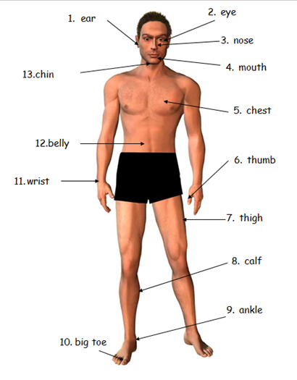
 | Possessive Adjective (my, his, her)
 |  | Singular noun
 | This is my daughter. | Her ear hurts.
 | This is my mother.
 | This is my husband.
 | This is Adam.
 | This is Eve.
 | This is my wife.
 | This is my Adam.
 | This is Tim.
 | This is my daughter.
 | This is my son.
 | This is my father.
 | This is my wife.
 | This is Eve.
 |  | Plural noun
1. | This is Adam. | His ears hurt.
2. | This is my husband.
5. | This is my daughter.
7. | This is Tim.
9. | This is my wife.
10. | This is Adam.
11. | This is Pam.

Past Present Future

What did you do … | What are you doing ….

yesterday today tomorrow
now last week next week
last year this week this year
next year now later

forms of the ‘be’ verb - is / am / are / was /were (auxiliary (helping) verbs)

pronoun | helping verb (present) | pronoun | helping verb (past)
I | am | I | was
He | is | He | was
She | is | She | was
It | is | It | was
You | are | You | were
We | are | We | were
They | are | They | were

Write the sentences with the main verbs in the past - is / are / am / was /were

pronoun | helping verb (past)
I |  | sick.
He |  | poorly.
She |  | tired.
It |  | cold.
You |  | thirsty.
We |  | hungry.
They |  | cold.

Write the sentences with the main verbs in the present - is / am / are / was /were

pronoun | helping verb (present)
I |  | sick.
He |  | poorly.
She |  | tired.
It |  | cold.
You |  | thirsty.
We |  | hungry.
They |  | cold.

forms of the ‘have’ verb - have / has / had / (auxiliary (helping) verbs)

pronoun | helping verb (present) | pronoun | helping verb (past)
I | have | I | had
He | has | He | had
She | has | She | had
It | has | It | had
You | have | You | had
We | have | We | had
They | have | They | had

Write the sentences with the main verbs in the past - have / has / had /

pronoun | helping verb | article | verb | noun
I |  | a | runny | nose.
He |  | a | poorly | stomach.
She |  |  | tired | eyes.
You |  | a | sore | throat.
We |  | a | bad | back.
They |  | a | poorly | belly.

Write the sentences with the main verbs in the present - have / has / had /

pronoun | helping verb | article | verb | noun
I |  | a | runny | nose.
He |  | a | poorly | stomach.
She |  |  | tired | eyes.
You |  | a | sore | throat.
We |  | a | bad | back.
They |  | a | poorly | belly.

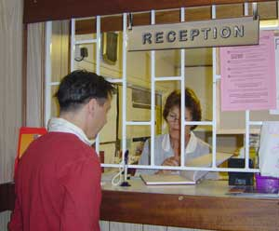
Reception

Receptionist

This is yourYour local family Health Services Authority (FHSA) is
NHS medical card
Please keep it in a safe place. It is proof LAMBETH, SOUTHWARK & LEWISHAM
that you are entitled to NHS treatment.1 LOWER MARSH
Your NHS number isWATERLOO
LONDON
MRSL 282SE1 7RJ
Please tell us this number if you get in touch with us. It
will help us find your records more quickly.

MRS. LUCY LISA SMITH
29 HARRIS ROAD
LONDON
SE15

SE15 1PS

Your doctor isYour date of birth
P R HALL (1478)14/06/1973

NHS Medical Card

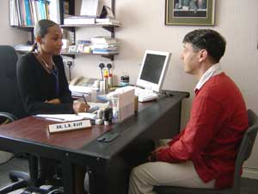

Leeds Road Surgery
Leeds Road SE4 1UT

0208 694 5565

Appointment with:

……………….………………..

on …… ……………................

at ………………………………
Dr Kim
Tue. May 3rd
10.15 a.m.
Appointment Card
Patient
Doctor

This is yourYour local family Health Services Authority (FHSA) is
NHS medical card
Please keep it in a safe place. It is proof LAMBETH, SOUTHWARK & LEWISHAM
that you are entitled to NHS treatment.1 LOWER MARSH
Your NHS number isWATERLOO
LONDON
MRSL 282SE1 7RJ
Please tell us this number if you get in touch with us. It
will help us find your records more quickly.

MRS. LUCY LISA SMITH
29 HARRIS ROAD
LONDON
SE15

SE15 1PS

Your doctor isYour date of birth
P R HALL (1478)14/06/1973

Leeds Road Surgery
Leeds Road SE4 1UT

0208 694 5565

Appointment with:

……………….………………..

on …… ……………................

at ………………………………
Dr Kim
Tue. May 3rd
10.15 a.m.

Mr Ali Can I make an appointment please?
Receptionist Is tomorrow at 9.30 OK?
Mr Ali Sorry, I can’t come in the morning because I go to college. Can I have an appointment in the afternoon please?
Receptionist OK. Is tomorrow at 5.45 OK?
Mr Ali Yes thank you, that’s OK.
Receptionist What’s your name please?
Mr Ali It’s John Ali.
Receptionist Okay Mr Ali. That’s tomorrow at 5.45.

Mr Ali …………………………………………………………………………………
Receptionist …………………………………………………………………………………
Mr Ali …………………………………………………………………………………
…………………………………………………………………………………
…………………………………………………………………………………
Receptionist …………………………………………………………………………………
Mr Ali …………………………………………………………………………………
Receptionist …………………………………………………………………………………
Mr Ali …………………………………………………………………………………
Receptionist …………………………………………………………………………………

Leeds Surgery
OPENING TIMES
Monday | 9 - 11 | 4 - 6
Tuesday | 9 – 11 | 4 – 6
Wednesday | 9 – 12 | 5 – 7
Thursday | 9 – 11 | 4 – 6
Friday | 9 – 11 | 3 - 5
Saturday  Sunday | CLOSED

What time is the surgery open?

- What time is the surgery open on Mondays?

It’s open from ………… to ………… and from ………… to ………….

- What time is the surgery open on Tuesdays?

It’s open from ………… to ………… and from ………… to ………….

- What time is the surgery open on Wednesdays?

It’s open from ………… to ………… and from ………… to ………….

- What time is the surgery open on Fridays?

It’s open from ………… to ………… and from ………… to ………….

- What time is the surgery open on Saturdays?

……………………………………………………………………………………………………….

- What time is the surgery open on Thursdays?

……………………………………………………………………………………………………….

Leeds Road Surgery
Leeds Road SE4 1UT

0208 694 5565

Appointment with:

……………….……………………

on …… …………….......................

at ………………………………….
Dr Kim
Tue. May 3rd
10.15 a.m.

My appointment is …………………………… Dr Kim.

My appointment is …………………………… Tuesday May 3rd.

My appointment is …………………………… 10.15 a.m.

on
with
at

Leeds Road Surgery  Leeds Road LS1 1UT  0208 694 5565  Appointment with:  ………………………………  on …………………………...  at …………………………… | Leeds Road Surgery  Leeds Road LS1 1UT  0208 694 5565  Appointment with:  ………………………………  on …………………………...  at ……………………………
Leeds Road Surgery  Leeds Road LS1 1UT  0208 694 5565  Appointment with:  ………………………………  on …………………………...  at …………………………… | Leeds Road Surgery  Leeds Road LS1 1UT  0208 694 5565  Appointment with:  ………………………………  on …………………………...  at ……………………………
Leeds Road Surgery  Leeds Road LS1 1UT  0208 694 5565  Appointment with:  ………………………………  on …………………………...  at …………………………… | Leeds Road Surgery  Leeds Road LS1 1UT  0208 694 5565  Appointment with:  ………………………………  on …………………………...  at ……………………………

Leeds Road Surgery

Dr Raif Wed 21 May |  | Dr Kim Tues 20 May
9.00 | Mr Jackson | 9.00 | Mrs Ahmadi
9.15 |  | 9.15 | Mr Nkosso
9.30 | Miss Ali | 9.30 | Ms Jones
9.45 | Mrs Abadi | 9.45
10.00 |  | 10.00 | Mr Bloggs
10.15 | Mr Mahmoud | 10.15 | Mrs Medelis
10.30 | Mr El-rani | 10.30 | Ms Solomons
10.45 | Ms Dkouso | 10.45 | Ms McKenzie
11.00 |  | 11.00 | Ms Allen
Dr Paul Thurs 22 May |  | Dr Ross Fri 22 May
4.00 | Mr Tutu | 4.00
4.15 | Mrs Tutu | 4.15
4.30 | Ms Herreman | 4.30 | Mrs McQuaid
4.45 | Mr McCollom | 4.45 | Mr McElroy
5.00 | Miss Brown | 5.00 | Miss Anton
5.15 | Mrs Abdi | 5.15 | Miss Crier
5.30 | Mr Mohamed | 5.30

 | When is your appointment? | It’s on ………………………………………………………………………
 | What time is your appointment? | It’s at ………………………………………………………………………
 | Where is your appointment? | It’s at ………………………………………………………………………
 | Who is your appointment with? | It’s with ………………………………………………………………….
 | When is your appointment? | …………………………………………………………………………………..
 | What time is your appointment? | …………………………………………………………………………………..
 | Where is your appointment? | …………………………………………………………………………………..
 | Who is your appointment with? | …………………………………………………………………………………..

 | When is your appointment? | It’s on ………………………………………………………………………
 | What time is your appointment? | It’s at ………………………………………………………………………
 | Where is your appointment? | It’s at ………………………………………………………………………
 | Who is your appointment with? | It’s with ………………………………………………………………….
 | When is your appointment? | …………………………………………………………………………………..
 | What time is your appointment? | …………………………………………………………………………………..
 | Where is your appointment? | …………………………………………………………………………………..
 | Who is your appointment with? | …………………………………………………………………………………..

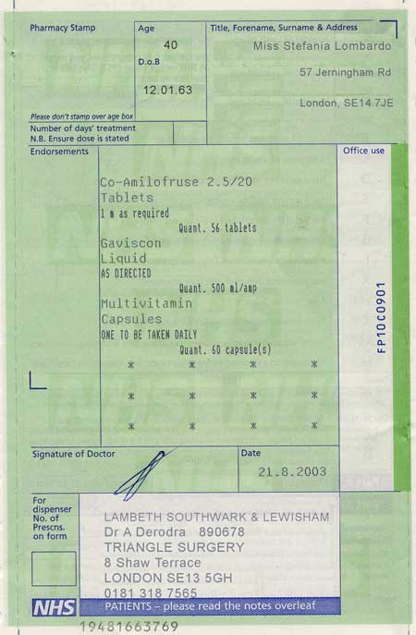

Title …………………………………………………………………………

Forename …………………………………………………………………

Surname ……………………………………………………………………

Address ……………………………………………………………………

……………………………………………………………………………………

Post Code …………………………………………………………………

DOB ……………………………………………………………………………

Age ……………………………………………………………………………

Doctor’s name …………………………………………………………

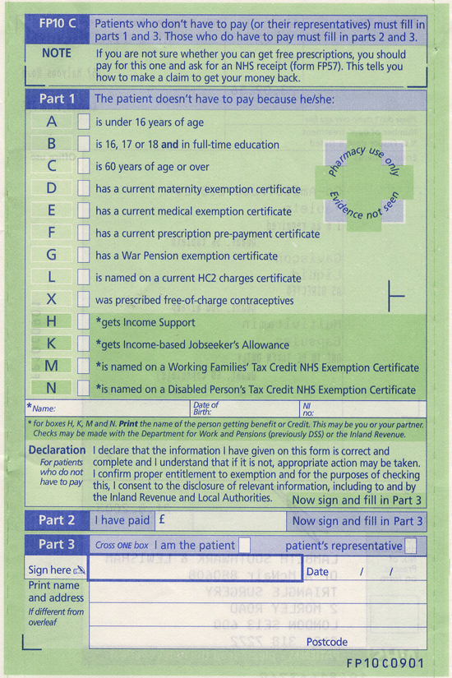

Tick the box. Fill in your name.

Fill in your Date of Birth. Fill in your National Insurance Number.

Sign your name.

