Talking about you and your family

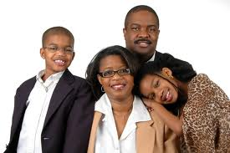

Question | Example | YOU: Yes / no | YOU: More information
Are you married or single? | I am married.
What is your husband / wife’s name? | His name is ________ / Her name is ____________
Do you have children?  How many? | Yes, I do.  I have 3 children.
Do you live with your family? | Yes, I live with my family.
What are your children’s names? | They are called Sara, Ben and Tom.
How old are your children? | They are 6, 10 and 15.
What does your husband / wife do for a job? | My husband is a doctor.  My wife is a teacher.
What do your children do at the weekend? | My son likes to play football.  My daughter enjoys painting.

Complete
I am | I’m
He is
She is
It is | It’s
You are
We are
They are | They’re
REMEMBER THESE?

Object pronouns

Write the missing pronouns

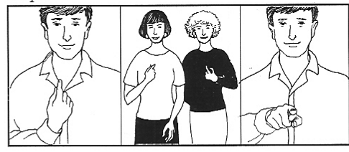
___________ _____________ _____________

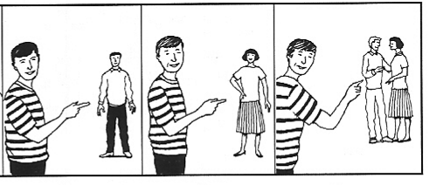
___________ _____________ _____________

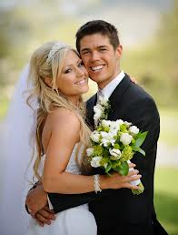 | 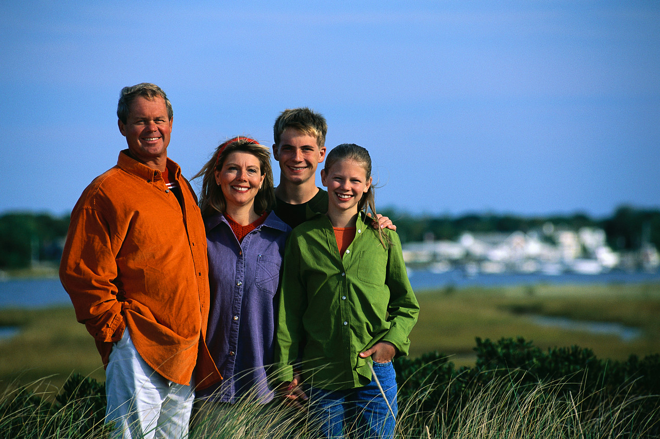
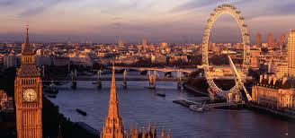 | 
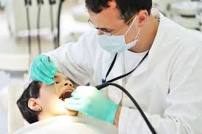 | 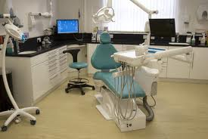
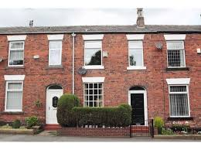 | 

terraced house | pet cats | married | family
London | dentist | nurse | dental surgery

This is Sally and her family

COPY

Father / Dad | Mother / Mum | Daughter / sister | Son / brother | Parents | Children

This is Mum. She is called Sally.
This is Dad. He is called Tom.
This is the daughter. She is called Kirsty. She has one brother.
This is the son. He is called Nick. He has one sister.

Mum – her name is
Dad – his name is
Daughter – her name is
Son – his name is
Children – their names are
Parents – their names are

.
Read about Sally’s family

This is Sally Milton.

She’s married, and this is her family.

Their terraced house is in London.

She’s a nurse.

Her hospital is in the centre of town.

Tom is Sally’s husband.
He’s a dentist.

His dental surgery is in the centre of town, too.

Our children are called Kirsty and Nick.

They’re students at Camden College.
We have two pet cats. Their names are Max and Cleo.

We’re happy. We love living in London.

This is Sally Milton.
She’s married, and this is her family.
Their terraced house is in London.
She’s a nurse.
Her hospital is in the centre of town.

Tom is Sally’s husband.
He’s a dentist.
His dental surgery is in the centre of town, too.

Our children are called Kirsty and Nick.
They’re students at Camden College.
We have two pet cats. Their names are Max and Cleo.
We’re happy. We love living in London.

Where do the family live? | They live in …
What is their house like?
What is Sally’s job?
What is Tom’s job?
Where does Sally work?
What are the children called?
What do the children do?
What are the cats called?

Does the family like London?

This is Sally Milton.
She’s married, and this is her family.
Their house is in London.
She’s a nurse.
Her hospital is in the centre of town.
Tom is Sally’s husband.
He’s a dentist.
His dental surgery is in the centre of town, too.
Our children are called Kirsty and Nick.
They’re students at Camden College.
We have two pet cats. Their names are Max and Cleo.
We’re happy. We love living in London.

The red words are all nouns.
Common nouns have no capital letter at the beginning.
Proper nouns are for titles, cities, countries and names. They must have a capital letter.
Fill in the table with nouns. Can you add any more of your own?

Common nouns  dentist | Proper nouns  London

Subject pronoun, possessive adjectives and apostrophes

She is married.
He is a dentist.
Her hospital is in the centre of town.
They’re students at Camden College.

Subject pronoun | I | you | she | he | we | they
Possessive adjective | my | your | her | his | our | their

She’s married. She’s a teacher. ‘s = is

This is her family.
This is Sally’s family. ‘s = the family of Sally.

His
Tom’s bank

Her
Kirsty’s college

Write sentences:

Sally. Family. | Sally’s family.
The family. House.
Sally. Husband.
Tom. Dental Surgery. | Tom’s dental surgery.
Sally. Hospital.
Kirsty. College.

SPEAKING.

In pairs. Ask and answer the questions. Give short answers.

Read again.
Answer the questions.

This is Sally Milton.
She’s married, and this is her family.
Their house is in London.
She’s a nurse.
Her hospital is in the centre of town.
Tom is Sally’s husband.
He’s a dentist.
His dental surgery is in the centre of town, too.
Our children are called Kirsty and Nick.
They’re students at Camden College.
We have two pet cats. Their names are Max and Cleo.
We’re happy. We love living in London.

Is Sally married? | Yes, she is.
Where’s their house?
What is Sally’s job?
Where’s her hospital?
What is Tom’s job?
Where is his dental surgery?
Are their children doctors?

 | mother | daughter | sister | wife
 | father | son | brother | husband
plural | parents | children | brothers / sisters | husbands / wives

Sally = Tom

Kirsty Nick

Complete:

Sally is Tom’s ___wife___. | Tom is Sally’s __________.
Kirsty is Sally and Tom’s _______________. | Nick is their ______________.
Sally is Nick’s ___________. | Tom is Kirsty’s _____________.
Kirsty is Nick’s _____________. | Nick is Kirsty’s ____________.
Sally and Tom are Kirsty and Nick’s ____________. | Kirsty and Nick are Tom and Sally’s ___________.

Wife children parents father mother brother sister

Your name and your husband’s name

__________ __________

Your children’s names

__________ _______________ ______________ _______________

Write sentences about your family like the ones in the example.
Use these words.

Wife children parents father mother brother sister

