Section 1 Words (open PowerPoint – Week2 Words 2)
Name: _______________________________ Date: ______________

Present one slide at a time, reading for the learners and getting them to mimic. Spell out words using phonics and standard letter sounds for Dolch words. Use this activity as a diagnostic, reading one letter at a time, asking them to repeat and write the letters on A4 paper or boards, and to show you, then moving onto the words and pronunciation. Drill the words. Later building the words into sentences. After a length of drilling using the PowerPoint, hand out these worksheets and ask them to complete the first column, writing down each word as you say it. Ask learners to compare with a peer and rewrite in the second column. Translate in the third column if possible. You could use Google translate (with prepared translations) or learners’ bilingual dictionaries.

 | First try | Second try | Translate (where possible)

Section 2 (Open Week 2 Sentences 2)
(1.) Display the blank dialogue on slides 2 and 3 of the PowerPoint. Provide cut outs of the words and ask students to sequence the words correctly in each speech bubble below. When correct glue them onto the page. (2.) Choose a learner, or a colleague, and model the dialogue below. Do the same with other learners to further model and use different nouns from previous lesson: office, reception, toilets, etc.


Section 3 Handwriting (Copy some words from page 2. Use this web resource to model pen direction.)

1.

2.

3.

4.

5.

6.

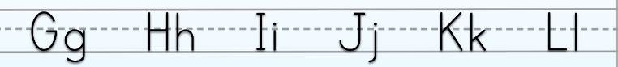

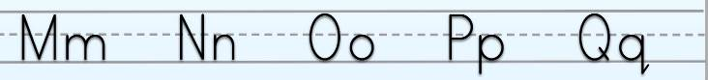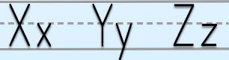

Section 5 find and correct the errors

Write the missing words.

Can you help me?
How can I help you?
Where is the office?
The __ __ __ __ __ is there.

__ __ __ you __ __ __ __ me?
How __ __ __ I help __ __ __?
__ __ __ __ __ is the lift?
The __ __ __ __ is __ __ __ __ __.

Can __ __ __ help __ __?
__ __ __ can I __ __ __ __ you?
Where is the library?
The __ __ __ __ __ __ __ is there.

__ __ __ you __ __ __ __ me?
How __ __ __ I help __ __ __?
Where are the toilets?
The __ __ __ __ __ __ __ are here.

Can __ __ __ help __ __?
__ __ __ can I __ __ __ __ you?
Where __ __ __ the stairs?
The __ __ __ __ __ __ are there.
Section 6 word shapes (lowercase letters)

1 2 3

4 5 6 7

8

can you help room

where is here there

Section 6 (Open Week 2 Sentences 2)
In pairs, role play asking questions and replying, using the map and previously taught words. Place the map in between the learners. One is speaker 1 and asks the questions and the other must reply as speaker 2, using the same word and pointing to the map to locate the place. Then swap speaker roles.
Can you help me?
How can I help you?
Where is the _____
The ______ is ____

Speaker 1 | Speaker 2
Can you help me?  Where is the office  are the toilets  reception  coffee area  stairs  lift  library  Where is room _____ | How can I help you?  The __________ is there / are here.  Room _____ is there.

Section 6 word search (capital letters) online click here to create more

E | K | T | H | E | R | E | D | P | I
T | H | E | J | P | V | P | R | U | Z
D | T | D | H | E | R | E | P | W | F
O | M | E | W | E | E | H | E | L | P
D | G | B | O | T | Z | C | A | N | R
O | P | V | Z | S | K | H | C | A | D
R | R | R | O | O | M | T | K | O | Y
Z | K | D | D | O | K | E | D | D | D
U | W | H | E | R | E | S | T | Q | R
Y | O | U | M | B | Z | H | O | W | O

HERE HOW ME THE ROOM

HELP CAN THERE YOU WHERE

Answer Key:
_ | _ | T | H | E | R | E | _ | _ | _
T | H | E | _ | _ | _ | _ | _ | _ | _
_ | _ | _ | H | E | R | E | _ | _ | _
_ | M | E | _ | _ | _ | H | E | L | P
_ | _ | _ | _ | _ | _ | C | A | N | _
_ | _ | _ | _ | _ | _ | _ | _ | _ | _
_ | _ | R | O | O | M | _ | _ | _ | _
_ | _ | _ | _ | _ | _ | _ | _ | _ | _
_ | W | H | E | R | E | _ | _ | _ | _
Y | O | U | _ | _ | _ | H | O | W | _

Section 7Spelling activity (read out the words from this week.)

Use LOOK SAY COVER WRITE CHECK

SPELLINGS

 | word | syllables | 1st try | 2nd try | 3rd try | 4th try
1
2
3
4
5
6
7
8
9
10



