Proper Nouns
We always use a capital letter for the name of people and places.

A person’s name | Ali Agba, Mary Smith
country, town, city | England Harehills Leeds
school, college, address | Harehills School Enfield Centre Enfield Terrace
months, days of the week | January Sunday

Underline the capital letters | Circle the mistakes | Write correctly | Write your address
Leeds City College  Enfield Centre  Enfield Terrace  Leeds  LS7 1RG | leeds city college  enfield centre  enfield terrace  leeds  ls7 1rg | ______________________  ______________________  ______________________  ______________________  ______________________ | ______________________  ______________________  ______________________  ______________________  ______________________

1 | Leeds Town Hall | 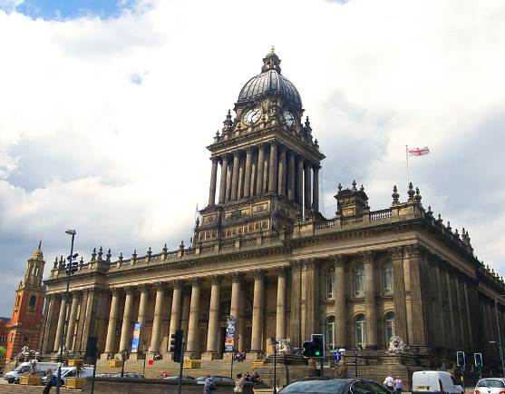 | 4 | Leeds City Museum | 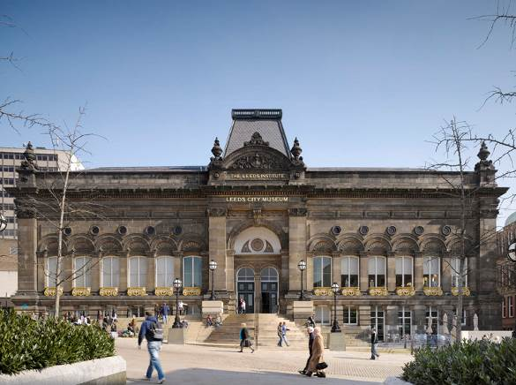
2 | Millennium Square | 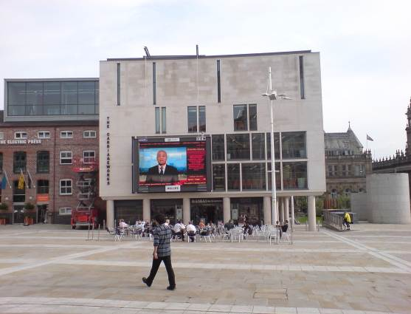 | 5 | Leeds Civic Hall | 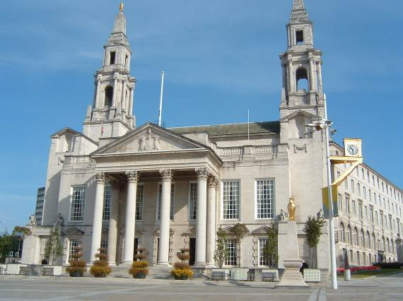
3 | Leeds Art Gallery | 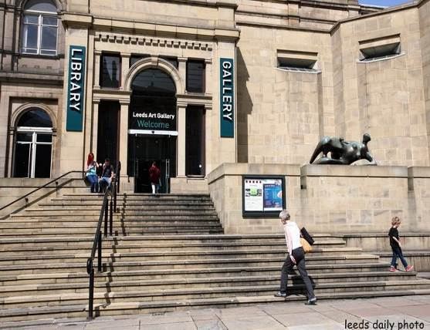 | 6 | Leeds Central Library | 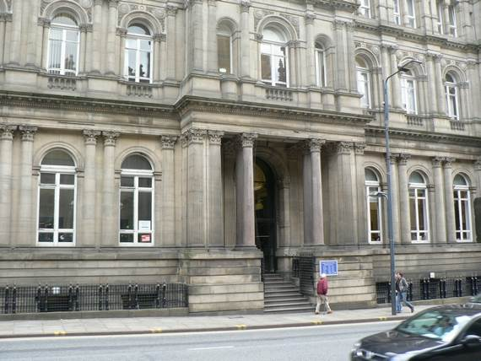

In pairs, ask questions: Have you been to …? Are you going to …?
Write the missing names, using capital letters
5.
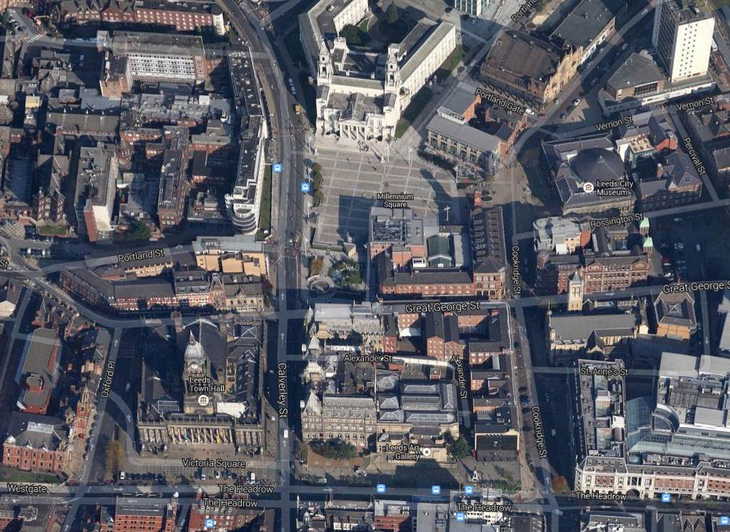
1.
2. Millennium Square
4.
3.
6.
1. leeds town hall 2. millennium square 3. leeds art gallery
4. leeds city museum 5. leeds civic hall 6. leeds central library

go straight ahead
third right
third left
second right
first right
second left
first left
Drawn a line
third right
third left
second right
first right
second left
first left

go straight ahead
Answer the tutor questions on how to find the different places. In pairs ask each other how to find the different places.

Leeds Civic Hall
Leeds City Museum

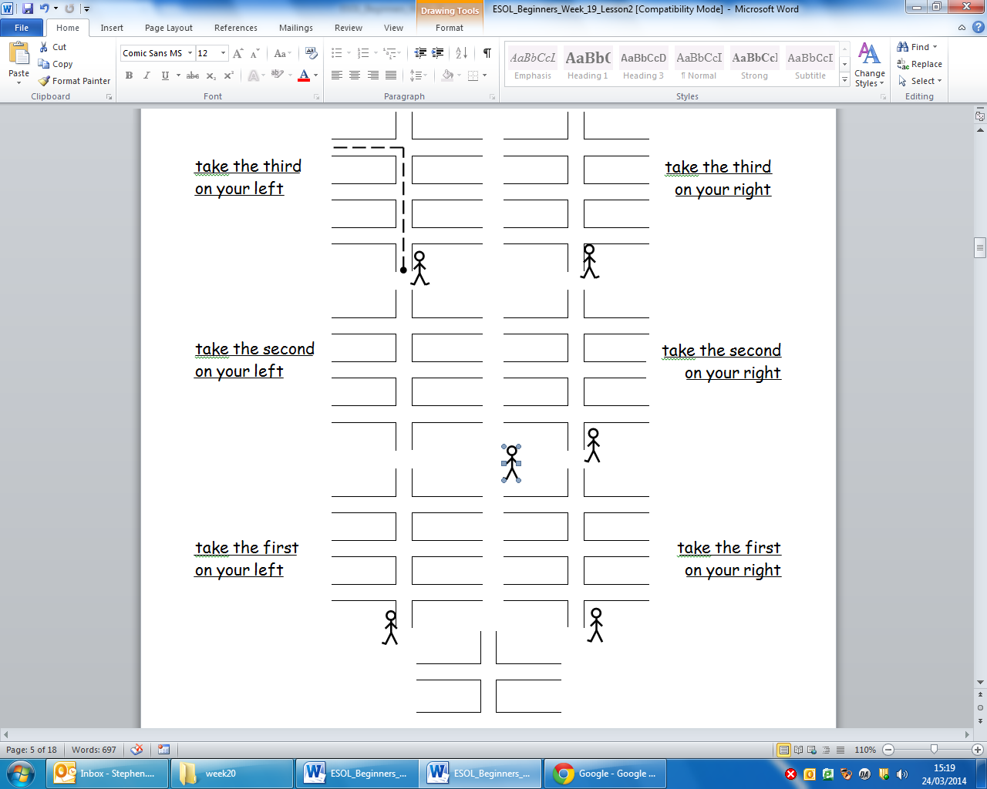
Leeds Town Hall
Leeds Art Gallery
Millennium Square
Leeds Central Library

Using these words, complete the directions

First Second Third Left Right Straight ahead

1 Excuse me, where is the Town Hall please?
2 Excuse me, where is the Art Gallery please?
3 Excuse me, where is the Civic Hall please?
4 Excuse me, where is the Millennium Square please?
5 Excuse me, where is the library please?
6 Excuse me, where is the museum please?
Frequency adverbs. Ask at least five people the questions below.

Excuse me, how often do you go to ….?

Name | Leeds |  | Museum |  | Art Gallery
 | Always | ✓ | Always |  | Always
 | Sometimes |  | Sometimes | ✓ | Sometimes | ✓
 | Never |  | Never |  | Never
 | Leeds |  | Museum |  | Art Gallery
 | Always |  | Always |  | Always
 | Sometimes |  | Sometimes |  | Sometimes
 | Never |  | Never |  | Never
 | Leeds |  | Museum |  | Art Gallery
 | Always |  | Always |  | Always
 | Sometimes |  | Sometimes |  | Sometimes
 | Never |  | Never |  | Never
 | Leeds |  | Museum |  | Art Gallery
 | Always |  | Always |  | Always
 | Sometimes |  | Sometimes |  | Sometimes
 | Never |  | Never |  | Never
 | Leeds |  | Museum |  | Art Gallery
 | Always |  | Always |  | Always
 | Sometimes |  | Sometimes |  | Sometimes
 | Never |  | Never |  | Never
 | Leeds |  | Museum |  | Art Gallery
 | Always |  | Always |  | Always
 | Sometimes |  | Sometimes |  | Sometimes
 | Never |  | Never |  | Never
 | Leeds |  | Museum |  | Art Gallery
 | Always |  | Always |  | Always
 | Sometimes |  | Sometimes |  | Sometimes
 | Never |  | Never |  | Never
 | Leeds |  | Museum |  | Art Gallery
 | Always |  | Always |  | Always
 | Sometimes |  | Sometimes |  | Sometimes
 | Never |  | Never |  | Never
 | Leeds |  | Museum |  | Art Gallery
 | Always |  | Always |  | Always
 | Sometimes |  | Sometimes |  | Sometimes
 | Never |  | Never |  | Never
 | Leeds |  | Museum |  | Art Gallery
 | Always |  | Always |  | Always
 | Sometimes |  | Sometimes |  | Sometimes
 | Never |  | Never |  | Never
 | Leeds |  | Museum |  | Art Gallery
 | Always |  | Always |  | Always
 | Sometimes |  | Sometimes |  | Sometimes
 | Never |  | Never |  | Never
 | Leeds |  | Museum |  | Art Gallery
 | Always |  | Always |  | Always
 | Sometimes |  | Sometimes |  | Sometimes
 | Never |  | Never |  | Never
 | Leeds |  | Museum |  | Art Gallery
 | Always |  | Always |  | Always
 | Sometimes |  | Sometimes |  | Sometimes
 | Never |  | Never |  | Never
 | Leeds |  | Museum |  | Art Gallery
 | Always |  | Always |  | Always
 | Sometimes |  | Sometimes |  | Sometimes
 | Never |  | Never |  | Never
 | Leeds |  | Museum |  | Art Gallery
 | Always |  | Always |  | Always
 | Sometimes |  | Sometimes |  | Sometimes
 | Never |  | Never |  | Never
 | Leeds |  | Museum |  | Art Gallery
 | Always |  | Always |  | Always
 | Sometimes |  | Sometimes |  | Sometimes
 | Never |  | Never |  | Never
Cut and paste the pictures into the spaces below.

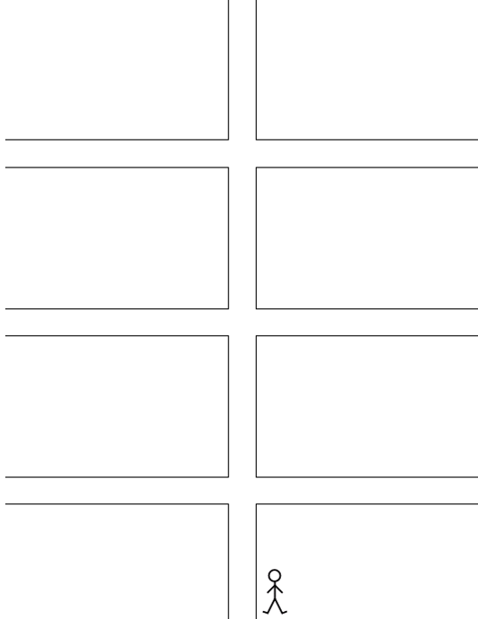
Look at your pictures and write your answers.

First Second Third Left Right Straight ahead

1 Excuse me, where is the Town Hall please?
2 Excuse me, where is the Millennium Square please?
3 Excuse me, where is the Art Gallery please?
4 Excuse me, where is the Museum please?
5 Excuse me, where is the Civic Hall please?
6 Excuse me, where is the Library please?

Look at page 8 and 9.

Choose people and write sentences in present simple tense.

 | Noun | frequency adverb | verb phrase | noun phrase
 | Stephen | always | goes to | Leeds.

Look at your sentences and write again in present continuous tense.

 | Noun | verb phrase | noun phrase
 | Stephen | is going to | Leeds.
Look at page 10. Write questions and answers for directions.
1. Excuse me, where is the ________________ please?
2 ________________________________________________
3 ________________________________________________
4 ________________________________________________
5 ________________________________________________
6 ________________________________________________

Leeds Town Hall |  | Leeds City Museum
Millennium Square |  | Leeds Civic Hall
Leeds Art Gallery |  | Leeds Central Library

Answer the tutor questions on how to find the different places. In pairs ask each other how to find the different places.

Leeds Civic Hall
Leeds City Museum
Calverley Street

Cookridge Street

Oxford Place

Leeds Town Hall
Leeds Art Gallery
Millennium Square
Leeds Central Library
The Headrow

The Headrow

Great George Street

Great George Street

