Name: _______________________________ Date: ______________

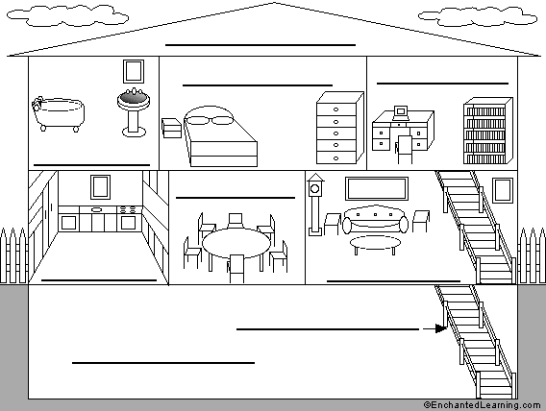
Open PowerPoint Week_15_rooms
Kitchen
Bedroom
Dining room
Bathroom
Living room
Bedroom; cut out the names from the back page and glue.

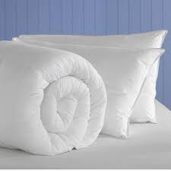 | 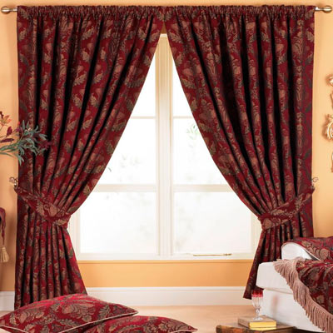
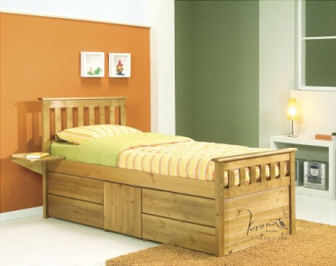 | 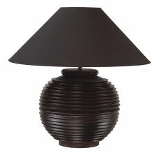
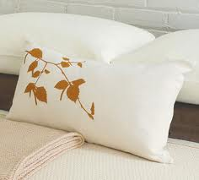 | 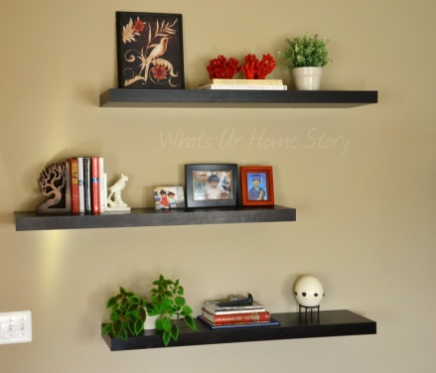
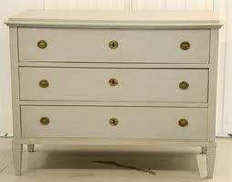

Draw your bedroom and label all the items.

Bathroom; cut out the names and glue to the picture.

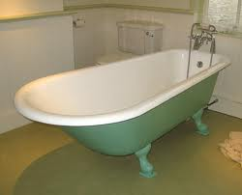 | 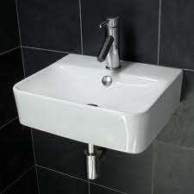
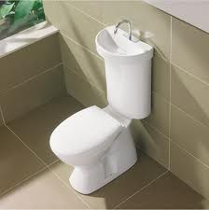 | 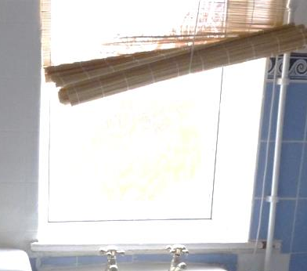
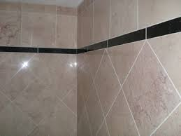 | 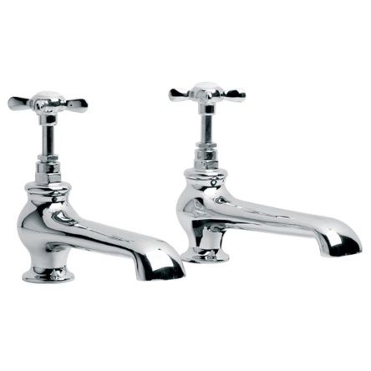


Draw your bathroom and label all the items.

Words (open PowerPoint – Week 15 Words 2)

 | spellings (listen to the tutor) | correct

(Open PowerPoint – Week 15 Sentences 2)

above on next to behind above

 | The shelves are _________ the bed. | 
 | The pillows are _______the duvet.
 | The drawers are _________ the bed.
 | The curtains are _________ the bed.
 | The light is _________ the bed.
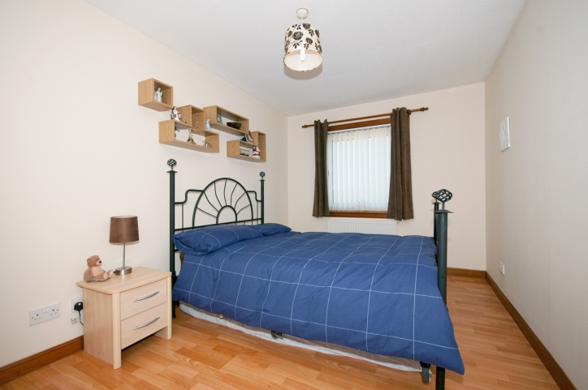
above on top of behind next to on
 | The blinds are _________ the sink.
 | The toilet paper is ___ _____ ___ the toilet.
 | The bath is _________ the door.
 | The sink is _________ the bath.
 | The tiles are _________ the wall.
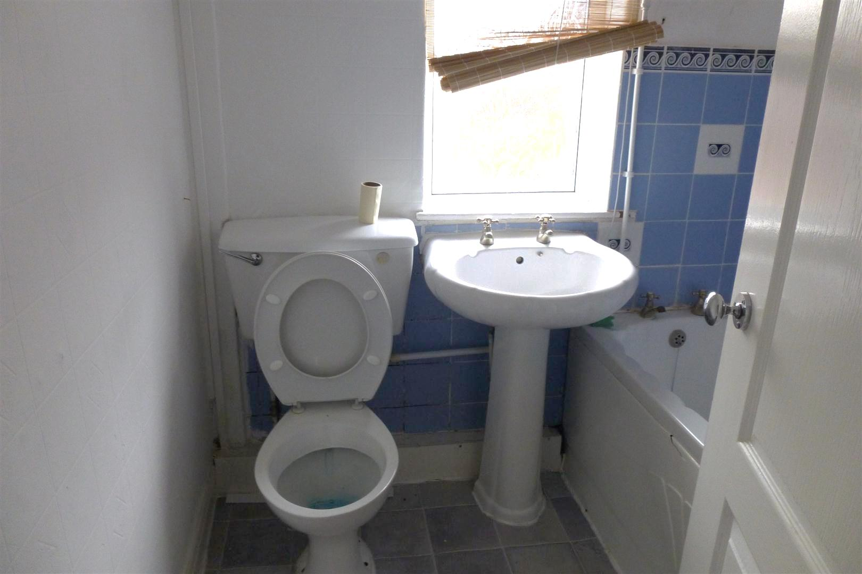

STUDENT 1 – Ask the other student “Where is the sink?” It is next to…

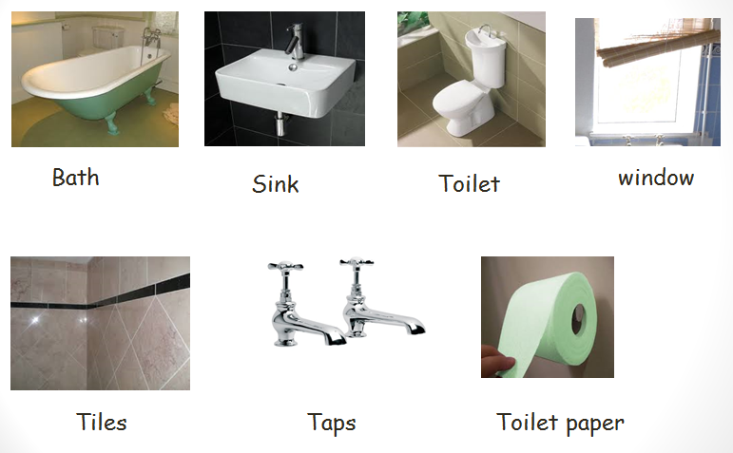

STUDENT 2 – Ask the other student “Where is the bed?” It is next to…

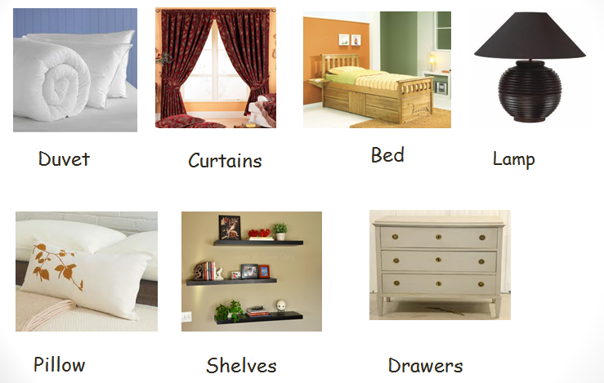

Bathroom

bath | sink
toilet | window
tiles | taps
toilet paper

Bedroom

duvet | curtains
bed | lamp
pillow | shelves
drawers

