Name: _______________________________ Date: ______________


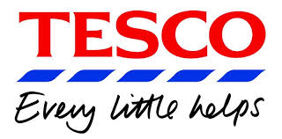




1. 2. 3. 4. 5.

Supermarket names

1 ____________________ 4 __________________
2 ____________________ 5 __________________
3 ____________________

Talk to another student using question words.

1. Where do you shop? ___________________
2. When do you shop? ___________________
3. What do you buy? ___________________
4. Why do you go shopping? ___________________
5. Which day do you go shopping? ___________________

Cut out the names from the back page and glue to the picture.

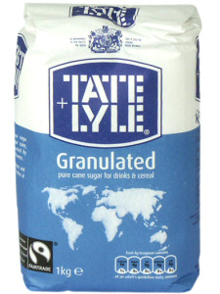 | 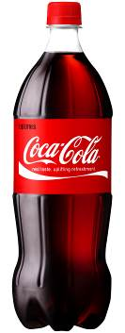
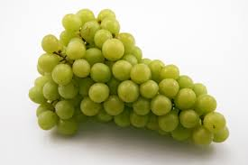 | 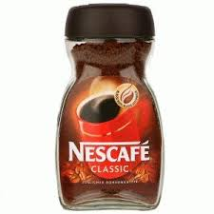
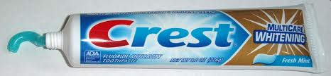 | 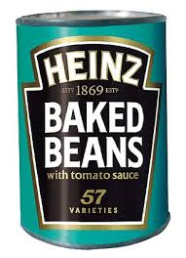
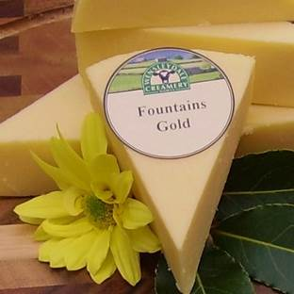 | 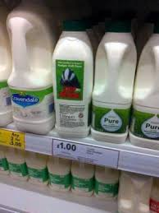
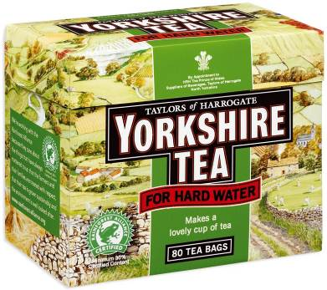 | 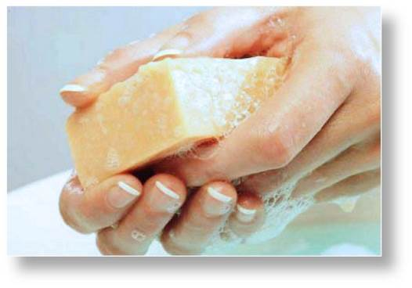
Write the missing words. Listen to your tutor read out the costs.
COST
- a bottle of ………………………… ________
- a block of ………………………. ________
- a box of …………………………… ________
- a carton of ……………………….. ________
- a bar of ……………………………. ________
- a bag of …………………………… ________
- a tin of ……………………………... ________
- a tube of ………………………….. ________
- a jar of ……………………………. ________
- a bunch of ……………………….. ________
Draw the shapes
bag | bunch
tin | bar
box | bottle
carton | jar
tube | block

Write the correct phrase
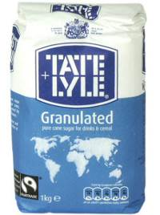 | 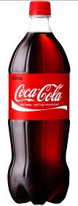
A bag of sugar | A coke
A grapes | A coffee
A toothpaste | A beans
A cheese | A milk
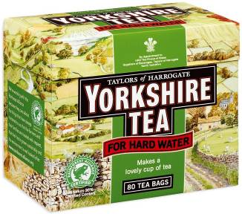 | 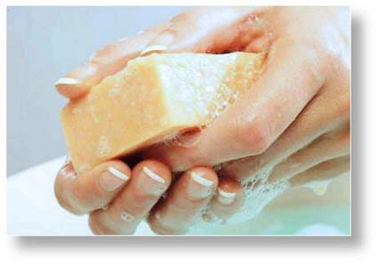
A teabags | A soap

Work in pairs and ask and answer each question.

1. What do you need? | 2. What do you need?
I need a bag of sugar. | I need a …
3. What do you need? | 4. What do you need?
I need a … | I need a …
5. What do you need? | 6. What do you need?
I need a … | I need a …
7. What do you need? | 8. What do you need?
I need a | I need a …
9. What do you need? | 10. What do you need?
I need a … | I need a …

Words (open PowerPoint – Week 13 Words 1)

 | spellings (listen to the tutor) | correct

T | Y | C | A | R | T | O | N | U | I | O | P
Q | A | S | D | V | U | W | G | H | J | K | A
B | A | R | L | Z | B | X | J | A | R | C | C
V | N | M | Q | W | E | R | T | Y | U | I | K
X | B | A | G | D | F | G | H | M | N | B | E
C | Z | E | P | R | S | L | I | P | B | X | T
R | E | K | B | O | T | T | L | E | W | M | A
U | Y | T | R | E | W | Q | I | N | C | K | M
A | B | C | D | H | I | J | K | T | L | I | N
S | T | L | I | T | R | E | U | I | B | L | C
I | M | V | W | H | I | S | P | N | E | O | T
Q | B | O | X | C | S | B | U | N | C | H | V

bottle bag packet tin bunch
box tube carton jar bar

(Open PowerPoint – Week 13 Sentences 1)

Read the sentences with your tutor and copy the sentences neatly. Answer the tutor questions.

Prepositions of time. We use:
- at for the TIME of day
- in for MONTHS, YEARS, CENTURIES and LONG PERIODS
- on for DAYS and DATES

 | Where did you go shopping? | 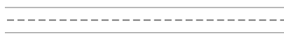
 | I went shopping at ASDA.
 | What food did you buy at ASDA?
 | I bought milk.
 | When does ASDA open?
 | It opens at 8 am.
 | When does ASDA close?
 | It closes at 10 pm.
 | Which day do you go shopping?
 | I go shopping on Friday.

STUDENT 1 - in pairs, read the sentences to the other student and copy.

Where did you go shopping?
___________________________________________
What food did you buy at ASDA?
___________________________________________
When does ASDA open? ___________________________________________
When does ASDA close? ___________________________________________
Which day do you go shopping?
___________________________________________

STUDENT 2 - in pairs, read the sentences to the other student and copy.

___________________________________________
I went shopping at ASDA.
___________________________________________
I bought milk.
___________________________________________
It opens at 8 am.
___________________________________________
It closes at 10 pm.
___________________________________________
I go shopping on Friday.

Write your own conversation with another student. Change the place, what you bought and the time.

Where did you go shopping?
I went shopping at ________
What food did you buy at ASDA?
I bought ________
When does ________ open?
It opens at ________.
When does ________ close?
It closes at ________.
Which day do you go shopping?
I go shopping on ______________.

AM | 1 | 2 | 3 | 4 | 5 | 6 | 7 | 8 | 9 | 10 | 11 | 12
PM | 1 | 2 | 3 | 4 | 5 | 6 | 7 | 8 | 9 | 10 | 11 | 12

Monday | Tuesday | Wednesday | Thursday | Friday | Saturday | Sunday
Write your own conversation with another student. Change the place, what you bought and the time.

Where did you go shopping?
I went shopping at ________
What food did you buy at ASDA?
I bought ________
When does ________ open?
It opens at ________.
When does ________ close?
It closes at ________.
Which day do you go shopping?
I go shopping on ________________.

AM | 1 | 2 | 3 | 4 | 5 | 6 | 7 | 8 | 9 | 10 | 11 | 12
PM | 1 | 2 | 3 | 4 | 5 | 6 | 7 | 8 | 9 | 10 | 11 | 12

Monday | Tuesday | Wednesday | Thursday | Friday | Saturday | Sunday

Think of other words you can put with the phrase.

- a bottle of ……………………………………………………
- a block of ……………………….…………………………
- a box of ………………………………………………………
- a carton of ………………………..…………………………
- a bar of …………………………….…………………………
- a bag of …………………………… …………………………
- a tin of ……………………………...…………………………
- a tube of …………………………..…………………………
- a jar of ……………………………. …………………………
- a bunch of ………………………..…………………………
TUTOR NOTE – add your own costs and read to the class
COST
- a bottle of ………pop………………… ________
- a block of ………cheese………………. ________
- a box of ………teabags…………………… ________
- a carton of ……milk………………….. ________
- a bar of …………soap…………………. ________
- a bag of …………sugar………………… ________
- a tin of ……………beans………………... ________
- a tube of ……toothpaste…………………….. ________
- a jar of …………coffee…………………. ________
- a bunch of ……grapes………………….. ________


sugar | teabags | coffee | soap | sugar
beans | cheese | milk | grapes | pop

